






Converse in English at a basic operational level
D1.LAN.CL10.01
Trainer Guide

Converse in English at a basic operational level

D1.LAN.CL10.01

Trainer Guide





Project Base
William Angliss Institute of TAFE
555 La Trobe Street
Melbourne 3000 Victoria
Telephone: | (03) 9606 2111
Facsimile: | (03) 9670 1330
Acknowledgements
Project Director: | Wayne Crosbie
Chief Writer: | Alan Hickman
Subject Writer: | Quentin Derrick
Project Manager  Editor: | Alan Maguire  Alan Maguire
DTP/Production | Daniel Chee, Mai Vu, Jirayu Thangcharoensamut, Kaly Quach

The Association of Southeast Asian Nations (ASEAN) was established on 8 August 1967. The Member States of the Association are Brunei Darussalam, Cambodia, Indonesia, Lao PDR, Malaysia, Myanmar, Philippines, Singapore, Thailand and Viet Nam.
The ASEAN Secretariat is based in Jakarta, Indonesia.
General Information on ASEAN appears online at the ASEAN Website: www.asean.org.
All text is produced by William Angliss Institute of TAFE for the ASEAN Project on “Toolbox Development for Priority Tourism Labour Division”.
This publication is supported by the Australian Government’s aid program through the ASEAN-Australia Development Cooperation Program Phase II (AADCP II).
Copyright: Association of Southeast Asian Nations (ASEAN) 2012.
All rights reserved.
Disclaimer
Every effort has been made to ensure that this publication is free from errors or omissions. However, you should conduct your own enquiries and seek professional advice before relying on any fact, statement or matter contained in this book. The ASEAN Secretariat and William Angliss Institute of TAFE are not responsible for any injury, loss or damage as a result of material included or omitted from this course. Information in this module is current at the time of publication. Time of publication is indicated in the date stamp at the bottom of each page.
Some images appearing in this resource have been purchased from stock photography suppliers Shutterstock and iStockphoto and other third party copyright owners and as such are non-transferable and non-exclusive. Clip arts, font images and illustrations used are from the Microsoft Office Clip Art and Media Library. Some images have been provided by and are the property of William Angliss Institute.
Additional images have been sourced from Flickr and SXC and are used under Creative Commons licence: http://creativecommons.org/licenses/by/2.0/deed.en

File name: TG_Converse_in_English_at_basic_op_level_refined





Table of contents
Competency Based Training (CBT) and assessment an introduction for trainers 1
Competency standard 11
Notes and PowerPoint slides 19
Recommended training equipment 85
Instructions for Trainers for using PowerPoint – Presenter View 87
Appendix – ASEAN acronyms 89

Competency Based Training (CBT) and assessment an introduction for trainers

Competency
Competency refers to the ability to perform particular tasks and duties to the standard of performance expected in the workplace.
Competency requires the application of specified knowledge, skills and attitudes relevant to effective participation, consistently over time and in the workplace environment.
The essential skills and knowledge are either identified separately or combined.
Knowledge identifies what a person needs to know to perform the work in an informed and effective manner.
Skills describe the application of knowledge to situations where understanding is converted into a workplace outcome.
Attitude describes the founding reasons behind the need for certain knowledge or why skills are performed in a specified manner.
Competency covers all aspects of workplace performance and involves:
- Performing individual tasks
- Managing a range of different tasks
- Responding to contingencies or breakdowns
- Dealing with the responsibilities of the workplace
- Working with others.

Unit of Competency
Like with any training qualification or program, a range of subject topics are identified that focus on the ability in a certain work area, responsibility or function.
Each manual focuses on a specific unit of competency that applies in the hospitality workplace.
In this manual a unit of competency is identified as a ‘unit’.
Each unit of competency identifies a discrete workplace requirement and includes:
- Knowledge and skills that underpin competency
- Language, literacy and numeracy
- Occupational safety and health requirements.
Each unit of competency must be adhered to in training and assessment to ensure consistency of outcomes.

Element of Competency
An element of competency describes the essential outcomes within a unit of competency.
The elements of competency are the basic building blocks of the unit of competency. They describe in terms of outcomes the significant functions and tasks that make up the competency.
In this manual elements of competency are identified as an ‘element’.

Performance criteria
Performance criteria indicate the standard of performance that is required to demonstrate achievement within an element of competency. The standards reflect identified industry skill needs.
Performance criteria will be made up of certain specified skills, knowledge and attitudes.

Learning
For the purpose of this manual learning incorporates two key activities:
- Training
- Assessment.
Both of these activities will be discussed in detail in this introduction.
Today training and assessment can be delivered in a variety of ways. It may be provided to participants:
- On-the-job – in the workplace
- Off-the-job – at an educational institution or dedicated training environment
- As a combination of these two options.
No longer is it necessary for learners to be absent from the workplace for long periods of time in order to obtain recognised and accredited qualifications.

Learning Approaches
This manual will identify two avenues to facilitate learning:
Competency Based Training (CBT)
This is the strategy of developing a participant’s competency.
Educational institutions utilise a range of training strategies to ensure that participants are able to gain the knowledge and skills required for successful:
- Completion of the training program or qualification
- Implementation in the workplace.
The strategies selected should be chosen based on suitability and the learning styles of participants.

Competency Based Assessment (CBA)
This is the strategy of assessing competency of a participant.
Educational institutions utilise a range of assessment strategies to ensure that participants are assessed in a manner that demonstrates validity, fairness, reliability, flexibility and fairness of assessment processes.

Flexibility in Learning
It is important to note that flexibility in training and assessment strategies is required to meet the needs of participants who may have learning difficulties. The strategies used will vary, taking into account the needs of individual participants with learning difficulties. However they will be applied in a manner which does not discriminate against the participant or the participant body as a whole.
Catering for Participant Diversity
Participants have diverse backgrounds, needs and interests. When planning training and assessment activities to cater for individual differences, trainers and assessors should:
- Consider individuals’ experiences, learning styles and interests
- Develop questions and activities that are aimed at different levels of ability
- Modify the expectations for some participants
- Provide opportunities for a variety of forms of participation, such as individual, pair and small group activities
- Assess participants based on individual progress and outcomes.
The diversity among participants also provides a good reason for building up a learning community in which participants support each other’s learning.
Participant Centred Learning
This involves taking into account structuring training and assessment that:
- Builds on strengths – Training environments need to demonstrate the many positive features of local participants (such as the attribution of academic success to effort, and the social nature of achievement motivation) and of their trainers (such as a strong emphasis on subject disciplines and moral responsibility). These strengths and uniqueness of local participants and trainers should be acknowledged and treasured
- Acknowledges prior knowledge and experience – The learning activities should be planned with participants’ prior knowledge and experience in mind
- Understands learning objectives – Each learning activity should have clear learning objectives and participants should be informed of them at the outset. Trainers should also be clear about the purpose of assignments and explain their significance to participants
- Teaches for understanding – The pedagogies chosen should aim at enabling participants to act and think flexibly with what they know
- Teaches for independent learning – Generic skills and reflection should be nurtured through learning activities in appropriate contexts of the curriculum. Participants should be encouraged to take responsibility for their own learning
- Enhances motivation – Learning is most effective when participants are motivated. Various strategies should be used to arouse the interest of participants
- Makes effective use of resources – A variety of teaching resources can be employed as tools for learning
- Maximises engagement – In conducting learning activities, it is important for the minds of participants to be actively engaged
- Aligns assessment with learning and teaching – Feedback and assessment should be an integral part of learning and teaching
- Caters for learner diversity – Trainers should be aware that participants have different characteristics and strengths and try to nurture these rather than impose a standard set of expectations.
Active Learning
The goal of nurturing independent learning in participants does not imply that they always have to work in isolation or solely in a classroom. On the contrary, the construction of knowledge in tourism and hospitality studies can often best be carried out in collaboration with others in the field. Sharing experiences, insights and views on issues of common concern, and working together to collect information through conducting investigative studies in the field (active learning) can contribute a lot to their eventual success.
Active learning has an important part to play in fostering a sense of community in the class. First, to operate successfully, a learning community requires an ethos of acceptance and a sense of trust among participants, and between them and their trainers. Trainers can help to foster acceptance and trust through encouragement and personal example, and by allowing participants to take risks as they explore and articulate their views, however immature these may appear to be. Participants also come to realise that their classmates (and their trainers) are partners in learning and solving.
Trainers can also encourage cooperative learning by designing appropriate group learning tasks, which include, for example, collecting background information, conducting small-scale surveys, or producing media presentations on certain issues and themes. Participants need to be reminded that, while they should work towards successful completion of the field tasks, developing positive peer relationships in the process is an important objective of all group work.

Competency Based Training (CBT)
Principle of Competency Based Training
Competency based training is aimed at developing the knowledge, skills and attitudes of participants, through a variety of training tools.
Training Strategies
The aims of this curriculum are to enable participants to:
- Undertake a variety of subject courses that are relevant to industry in the current environment
- Learn current industry skills, information and trends relevant to industry
- Learn through a range of practical and theoretical approaches
- Be able to identify, explore and solve issues in a productive manner
- Be able to become confident, equipped and flexible managers of the future
- Be ‘job ready’ and a valuable employee in the industry upon graduation of any qualification level.
To ensure participants are able to gain the knowledge and skills required to meet competency in each unit of competency in the qualification, a range of training delivery modes are used.
Types of Training
In choosing learning and teaching strategies, trainers should take into account the practical, complex and multi-disciplinary nature of the subject area, as well as their participant’s prior knowledge, learning styles and abilities.
Training outcomes can be attained by utilising one or more delivery methods:
Lecture/Tutorial
This is a common method of training involving transfer of information from the trainer to the participants. It is an effective approach to introduce new concepts or information to the learners and also to build upon the existing knowledge. The listener is expected to reflect on the subject and seek clarifications on the doubts.
Demonstration
Demonstration is a very effective training method that involves a trainer showing a participant how to perform a task or activity. Through a visual demonstration, trainers may also explain reasoning behind certain actions or provide supplementary information to help facilitate understanding.
Group Discussions
Brainstorming in which all the members in a group express their ideas, views and opinions on a given topic, is a free flow and exchange of knowledge among the participants and the trainer. The discussion is carried out by the group on the basis of their own experience, perceptions and values. This will facilitate acquiring new knowledge. When everybody is expected to participate in the group discussion, even the introverted persons will also get stimulated and try to articulate their feelings.
The ideas that emerge in the discussions should be noted down and presentations are to be made by the groups. Sometimes consensus needs to be arrived at on a given topic. Group discussions are to be held under the moderation of a leader guided by the trainer. Group discussion technique triggers thinking process, encourages interactions and enhances communication skills.
Role Play
This is a common and very effective method of bringing into the classroom real life situations, which may not otherwise be possible. Participants are made to enact a particular role so as to give a real feel of the roles they may be called upon to play. This enables participants to understand the behaviour of others as well as their own emotions and feelings. The instructor must brief the role players on what is expected of them. The role player may either be given a ready-made script, which they can memorise and enact, or they may be required to develop their own scripts around a given situation. This technique is extremely useful in understanding creative selling techniques and human relations. It can be entertaining and energising and it helps the reserved and less literate to express their feelings.

Simulation Games
When trainees need to become aware of something that they have not been conscious of, simulations can be a useful mechanism. Simulation games are a method based on "here and now" experience shared by all the participants. The games focus on the participation of the trainees and their willingness to share their ideas with others. A "near real life" situation is created providing an opportunity to which they apply themselves by adopting certain behaviour. They then experience the impact of their behaviour on the situation. It is carried out to generate responses and reactions based on the real feelings of the participants, which are subsequently analysed by the trainer.
While use of simulation games can result in very effective learning, it needs considerable trainer competence to analyse the situations.
Individual /Group Exercises
Exercises are often introduced to find out how much the participant has assimilated. This method involves imparting instructions to participants on a particular subject through use of written exercises. In the group exercises, the entire class is divided into small groups, and members are asked to collaborate to arrive at a consensus or solution to a problem.
Case Study
This is a training method that enables the trainer and the participant to experience a real life situation. It may be on account of events in the past or situations in the present, in which there may be one or more problems to be solved and decisions to be taken. The basic objective of a case study is to help participants diagnose, analyse and/or solve a particular problem and to make them internalise the critical inputs delivered in the training. Questions are generally given at the end of the case study to direct the participants and to stimulate their thinking towards possible solutions. Studies may be presented in written or verbal form.
Field Visit
This involves a carefully planned visit or tour to a place of learning or interest. The idea is to give first-hand knowledge by personal observation of field situations, and to relate theory with practice. The emphasis is on observing, exploring, asking questions and understanding. The trainer should remember to brief the participants about what they should observe and about the customs and norms that need to be respected.
Group Presentation
The participants are asked to work in groups and produce the results and findings of their group work to the members of another sub-group. By this method participants get a good picture of each other's views and perceptions on the topic and they are able to compare them with their own point of view. The pooling and sharing of findings enriches the discussion and learning process.
Practice Sessions
This method is of paramount importance for skills training. Participants are provided with an opportunity to practice in a controlled situation what they have learnt. It could be real life or through a make-believe situation.

Games
This is a group process and includes those methods that involve usually fun-based activity, aimed at conveying feelings and experiences, which are everyday in nature, and applying them within the game being played. A game has set rules and regulations, and may or may not include a competitive element. After the game is played, it is essential that the participants be debriefed and their lessons and experiences consolidated by the trainer.
Research
Trainers may require learners to undertake research activities, including online research, to gather information or further understanding about a specific subject area.

Competency Based Assessment (CBA)
Principle of Competency Based Assessment
Competency based assessment is aimed at compiling a list of evidence that shows that a person is competent in a particular unit of competency.
Competencies are gained through a multitude of ways including:
- Training and development programs
- Formal education
- Life experience
- Apprenticeships
- On-the-job experience
- Self-help programs.
All of these together contribute to job competence in a person. Ultimately, assessors and participants work together, through the ‘collection of evidence’ in determining overall competence.
This evidence can be collected:
- Using different formats
- Using different people
- Collected over a period of time.
The assessor, who is ideally someone with considerable experience in the area being assessed, reviews the evidence and verifies the person as being competent or not.
Flexibility in Assessment
Whilst allocated assessment tools have been identified for this subject, all attempts are made to determine competency and suitable alternate assessment tools may be used, according to the requirements of the participant.
The assessment needs to be equitable for all participants, taking into account their cultural and linguistic needs.
Competency must be proven regardless of:
- Language
- Delivery Method
- Assessment Method.
Assessment Objectives
The assessment tools used for subjects are designed to determine competency against the ‘elements of competency’ and their associated ‘performance criteria’.
The assessment tools are used to identify sufficient:
- Knowledge, including underpinning knowledge
- Skills
- Attitudes
Assessment tools are activities that trainees are required to undertake to prove participant competency in this subject.
All assessments must be completed satisfactorily for participants to obtain competence in this subject. There are no exceptions to this requirement, however, it is possible that in some cases several assessment items may be combined and assessed together.
Types of Assessment
Allocated Assessment Tools
There are a number of assessment tools that are used to determine competency in this subject:
- Work projects
- Written questions
- Oral questions
- Third Party Report
- Observation Checklist.
Instructions on how assessors should conduct these assessment methods are explained in the Assessment Manuals.
Alternative Assessment Tools
Whilst this subject has identified assessment tools, as indicated above, this does not restrict the assessor from using different assessment methods to measure the competency of a participant.
Evidence is simply proof that the assessor gathers to show participants can actually do what they are required to do.
Whilst there is a distinct requirement for participants to demonstrate competency, there are many and diverse sources of evidence available to the assessor.
Ongoing performance at work, as verified by a supervisor or physical evidence, can count towards assessment. Additionally, the assessor can talk to customers or work colleagues to gather evidence about performance.
A range of assessment methods to assess competency include:
- Practical demonstrations
- Practical demonstrations in simulated work conditions
- Problem solving
- Portfolios of evidence
- Critical incident reports
- Journals
- Oral presentations
- Interviews
- Videos
- Visuals: slides, audio tapes
- Case studies
- Log books
- Projects
- Role plays
- Group projects
- Group discussions
- Examinations.
Recognition of Prior Learning
Recognition of Prior Learning is the process that gives current industry professionals who do not have a formal qualification, the opportunity to benchmark their extensive skills and experience against the standards set out in each unit of competency/subject.
Also known as a Skills Recognition Audit (SRA), this process is a learning and assessment pathway which encompasses:
- Recognition of Current Competencies (RCC)
- Skills auditing
- Gap analysis and training
- Credit transfer.
Assessing competency
As mentioned, assessment is the process of identifying a participant’s current knowledge, skills and attitudes sets against all elements of competency within a unit of competency. Traditionally in education, grades or marks were given to participants, dependent on how many questions the participant successfully answered in an assessment tool.
Competency based assessment does not award grades, but simply identifies if the participant has the knowledge, skills and attitudes to undertake the required task to the specified standard.
Therefore, when assessing competency, an assessor has two possible results that can be awarded:
- Pass Competent (PC)
- Not Yet Competent (NYC).
Pass Competent (PC)
If the participant is able to successfully answer or demonstrate what is required, to the expected standards of the performance criteria, they will be deemed as ‘Pass Competent’ (PC).
The assessor will award a ‘Pass Competent’ (PC) if they feel the participant has the necessary knowledge, skills and attitudes in all assessment tasks for a unit.
Not Yet Competent’ (NYC)
If the participant is unable to answer or demonstrate competency to the desired standard, they will be deemed to be ‘Not Yet Competent’ (NYC).
This does not mean the participant will need to complete all the assessment tasks again. The focus will be on the specific assessment tasks that were not performed to the expected standards.
The participant may be required to:
a) Undertake further training or instruction
b) Undertake the assessment task again until they are deemed to be ‘Pass Competent’.

Competency standard
UNIT TITLE: CONVERSE IN ENGLISH AT A BASIC OPERATIONAL LEVEL |  |  |  |  | NOMINAL HOURS: 120
UNIT NUMBER: D1.LAN.CL10.01
UNIT DESCRIPTOR: This unit deals with the skills and knowledge required to converse orally in English in the workplace at a basic operational level.
ELEMENTS AND PERFORMANCE CRITERIA | UNIT VARIABLE AND ASSESSMENT GUIDE
Element 1: Participate in simple conversations on familiar topics with work colleagues  - Use and respond appropriately to opening comments  - Comment on familiar topics  - Talk about a past event  - Use closing remarks appropriately to end the conversation  Element 2: Respond to simple verbal instructions or requests  - Confirm understanding of supervisor’s instructions or requests  - Request repetition or clarification of instructions or requests  Element 3: Make simple requests  - Use polite forms to make simple requests  - Thank the person responding to your request  - Acknowledge the person who cannot respond to your request | Unit Variables  The Unit Variables provide advice to interpret the scope and context of this unit of competence, allowing for differences between enterprises and workplaces. It relates to the unit as a whole and facilitates holistic assessment. This unit applies where conversing in English at a basic operational level is required within the labour divisions of the hotel and travel industries and may include:  - Front Office  - Housekeeping  - Food and Beverage Service  - Food Production  - Travel Agencies  - Tour Operation  Opening comments may include:  How are you?  How did your shift go?  Is there anything I need to know?  You should be aware.
Element 4: Describe routine procedures  - Explain a sequence of events in carrying out a routine job  - Describe exceptions to routine procedures  - Make suggestions on how to improve routine procedures  Element 5: Express likes, dislikes and preferences  - Talk about likes and dislikes of familiar topics and situations  - Discuss preferences and give reasons  Element 6: Identify different forms of expression in English  6.1 Construct a formal sentence  6.2 Identify indicators of informal expressions in English  6.3 Differentiate between ‘open-ended’ and ‘closed’ questions | Familiar topics may include:  Giving directions  Providing advice on the best places to shop, eat, hear music, view art, etc  Providing advice about a customer’s special needs  Providing information  Referring a customer complaint to a supervisor.  Closing remarks may include:  I hope you enjoy your stay/tour  Goodbye and I hope we see you again soon  Thank you for staying at…; Please enjoy your tour.  Confirm understanding of supervisor’s information or requests may include:  So you want me to …?  I understand you would like me to …  Ways to seek repetition or clarification may include:  Asking the person to repeat themselves, e.g.  - Would you mind saying that again?  - Sorry I didn’t catch that  - Sorry I missed that  - Can you go over that again? Can you say that again please?  Seeking clarification, e.g.  - What should I do when I finish that?  - You would like me to swap shifts with you?
Polite forms used for making requests may include:
I wonder if you would do my afternoon shift for me tomorrow?
Would it be possible to swap shifts?
Could I change shifts because I have to …?
Sequence markers may include:
First
Then
After that
Next
At the end
Finally.
Exceptions to routine procedures may include:
Sometimes …happens.
Occasionally, I …
When … happens, I usually …but this doesn’t happen very often.
Ways to make suggestions may include:
Why don’t I check that for you?
I think it would be a good idea if …
How about …?
Let’s …
I think it would be a good idea if you …
A formal sentence refers to:
Written or verbal language that is grammatically correct and uses the correct tense consistently within the same sentence or paragraph
A sentence using modals, such as would, could.
Informal expressions in English refers to:
Written or verbal language that may not be grammatically correct and/or may contain colloquialisms, or expletives, or slang words.
An ‘open-ended’ question refers to:
A question that is phrased to obtain a full answer e.g. ‘where would you like to go?’
A ‘closed’ question refers to:
A question that forces a choice e.g. a ‘yes’ or ‘no’ answer.
Assessment Guide
The following skills and knowledge must be assessed as part of this unit:
Ability to distinguish formal and informal expressions in English
Ability to initiate conversations
Ability to respond to opening conversation remarks
Ability to keep a conversation going on familiar topics
Ability to talk about past events using sequence markers and correct tense
Ability to close a conversation politely
Ability to ask pertinent questions to clarify instructions and requests
Ability to make polite requests
Ability to explain routine work procedures
Ability to make suggestions
Ability to discuss likes, dislikes and preferences.
Linkages To Other Units
This unit may link to other ASEAN competency standards including:
Communicate in English on a telephone
Communicate on the telephone
Read and write English at a basic operational level
Respond to instructions given in English
Write a short message in English.
Critical Aspects of Assessment
Evidence of the following is essential:
Understanding of the differences between formal and informal English
Demonstrated ability to use polite forms
Demonstrated ability to participate in day to day casual conversations
Demonstrated ability to use correct ‘open’ and ‘closed’ question forms; this includes the use of auxiliary verbs and questions
Demonstrated ability to make polite requests; this includes the correct use of modals, such as would and could
Demonstrated ability to explain routine procedures; this includes the correct use of sequence markers such as first, then, etc. and the use of adverbs to describe exceptions to routine procedures such as: usually, sometimes, often, occasionally
Demonstrated ability to make suggestions; this includes the correct use of modals, such as could and would
Demonstrated ability to express likes, dislikes and preferences; this includes the correct use of verb forms.
Context of Assessment
Assessment must ensure:
Actual or simulated workplace application of situations where people converse at a basic operational level in the workplace.
Resource implications
Training and assessment must ensure there is access to suitably qualified English as a second language (ESL) teachers.
Assessment Methods
The following methods may be used to assess competency for this unit:
Observation of practical candidate performance
Interviews
Role plays
Oral and written questions.
Key Competencies in this Unit
Level 1 = competence to undertake tasks effectively
Level 2 = competence to manage tasks
Level 3 = competence to use concepts for evaluating and reshaping tasks
 | Key Competencies |  | Level | Examples
 | Collecting, organizing and analysing information |  | 1 | Talk about familiar topics such as work routines, sport, the weather, current events
 | Communicating ideas and information |  | 1 | Participate in short casual conversations on familiar topics
 | Planning and organizing activities |  | 1 | Discuss routine work procedures
 | Working with others and in teams |  | 1 | Express likes, dislikes and preferences
 | Using mathematical ideas and techniques |  | 1 | Talk about time required to complete work tasks
 | Solving problems |  | 1 | Make suggestions
 | Using technology |  | 1 | Use a computer or photocopier

Notes and PowerPoint slides
Slide
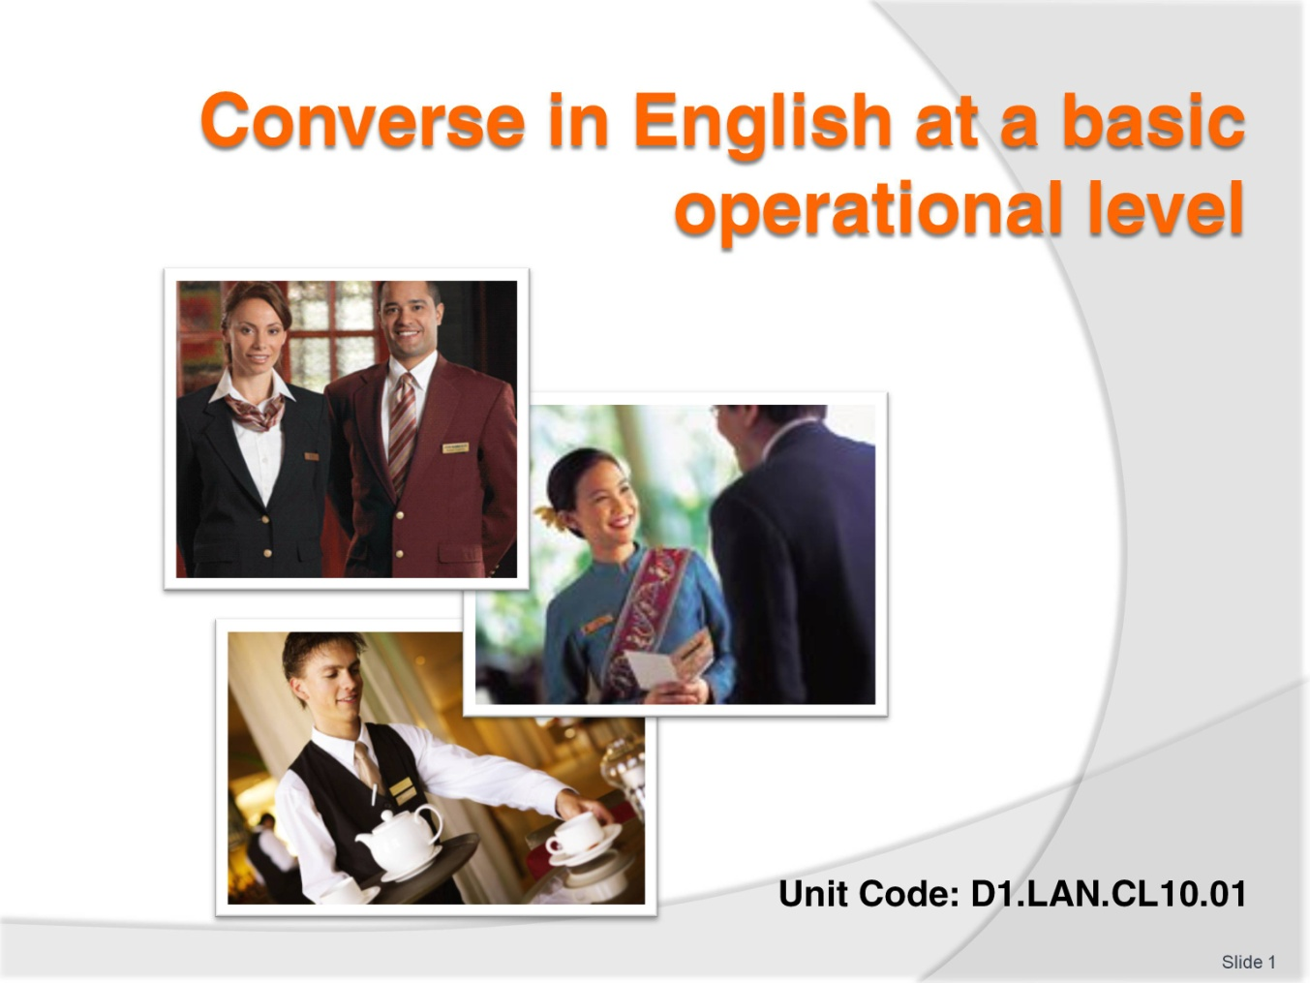
Slide No | Trainer Notes
 | Trainer to welcome class.

Slide
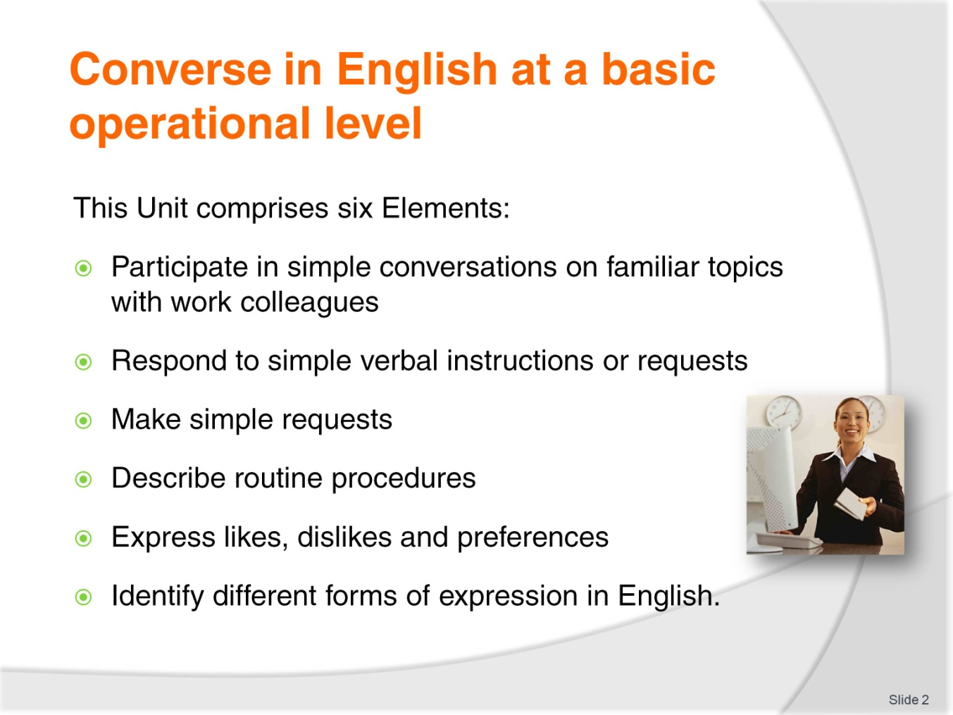
Slide No | Trainer Notes
Trainer advises students this Unit comprises six Elements, as listed on the slide explaining:
Each element comprises a number of Performance Criteria which will be identified throughout the class and explained in detail
Students can obtain more detail from their Trainee Manual
The course presents advice and information but where their workplace requirements differ to what is presented, the workplace practices and standards must be observed.

Slide
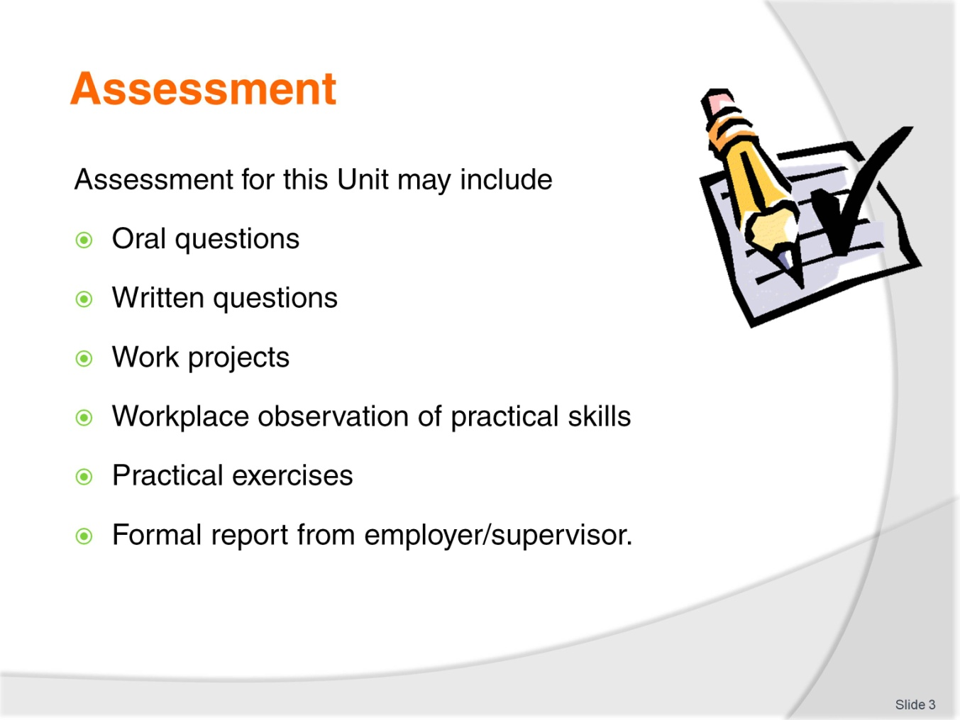
Slide No | Trainer Notes
Trainer advises students that assessment for this Unit may take several forms all of which are aimed at verifying they have achieved competency for the Unit as required.
Trainer indicates to students the methods of assessment that will be applied to them for this Unit.

Slide
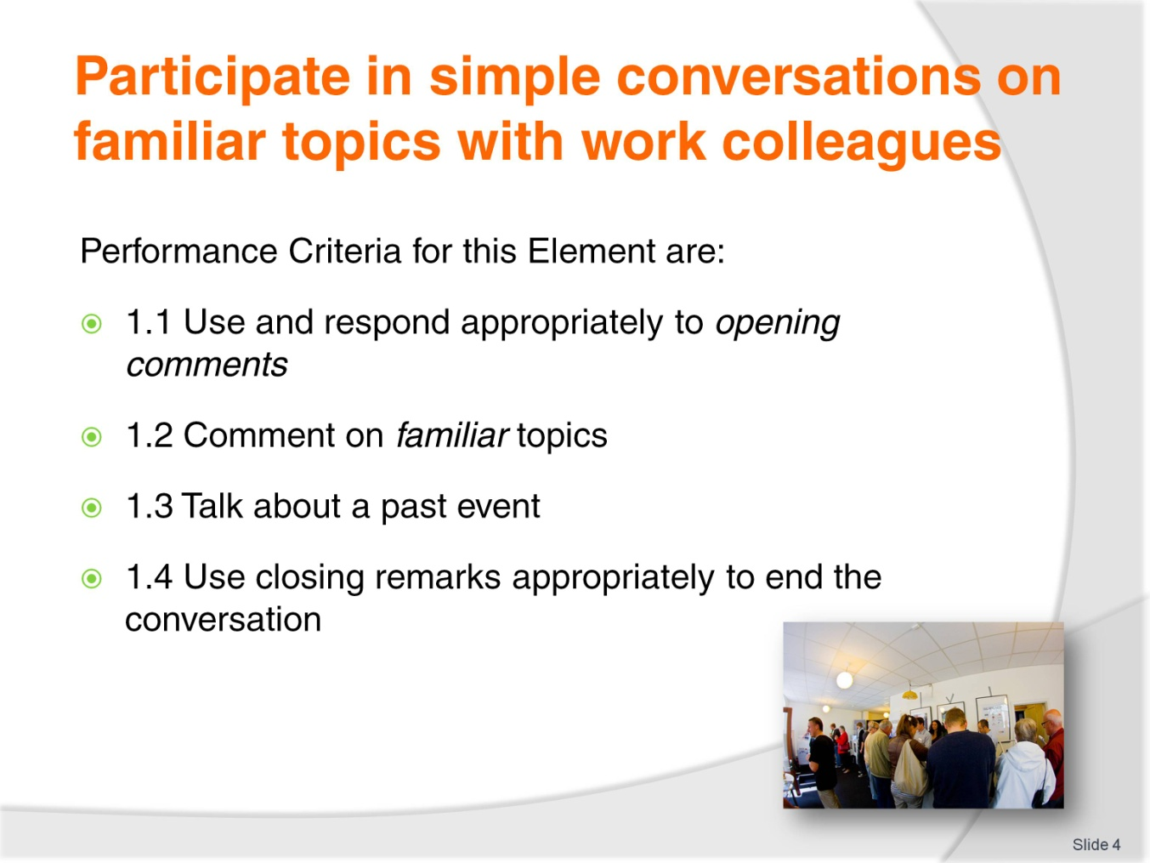
Slide No | Trainer Notes
Trainer identifies the Performance Criteria for this Element, as listed on the slide.
Class Activity – General discussion
Trainer leads a general class discussion on conversations in the workplace, asking questions such as:
How often do you talk to colleagues at work?
What are some ways that you can start a conversation?
What kinds of things do you typically talk about?
Do you talk about very formal topics or topics that you know well?
What are some ‘familiar’ topics?
How do we talk about events that happened before now?
When you are finished talking, how do you end the conversation?

Slide

Slide No | Trainer Notes
Trainer asks students how they approach someone if they want to talk to him/her. Trainer asks what kinds of things they usually say. Trainer calls on one particular student to ask about a conversation they had before class (this requires a little preparation before class). Trainer asks the student what he/she said to start the conversation and how that statement prepared the student to take part in the conversation.
Trainer explains to students that opening statements are very important because they:
Start a conversation
Tell the listener the purpose of the conversation
Give direction on how to continue the conversation.

Slide
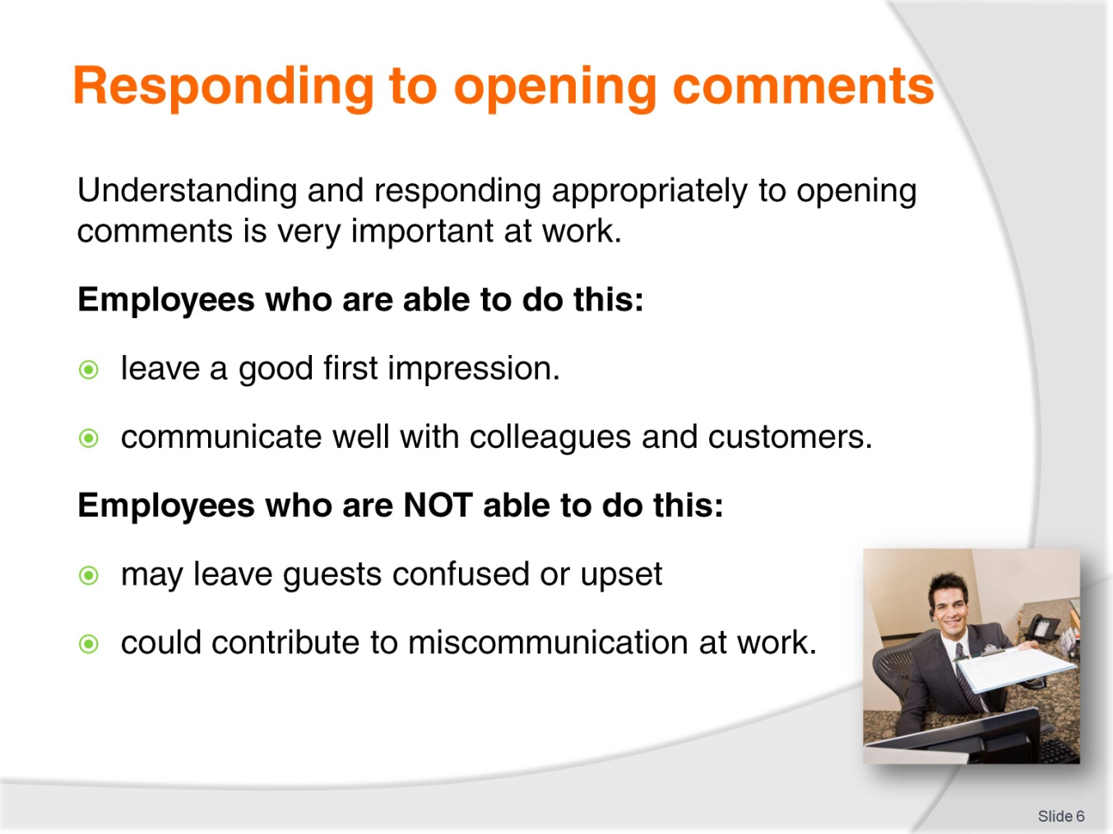
Slide No | Trainer Notes
Trainer explains the potential positive and negative consequences of opening statements in a professional setting.
Positive consequences include:
Leaving a good first impression
Communicating well with colleagues and customers.
Negative consequences include:
Possibly leaving guests confused or upset
Contributing to miscommunication in the workplace.

Slide
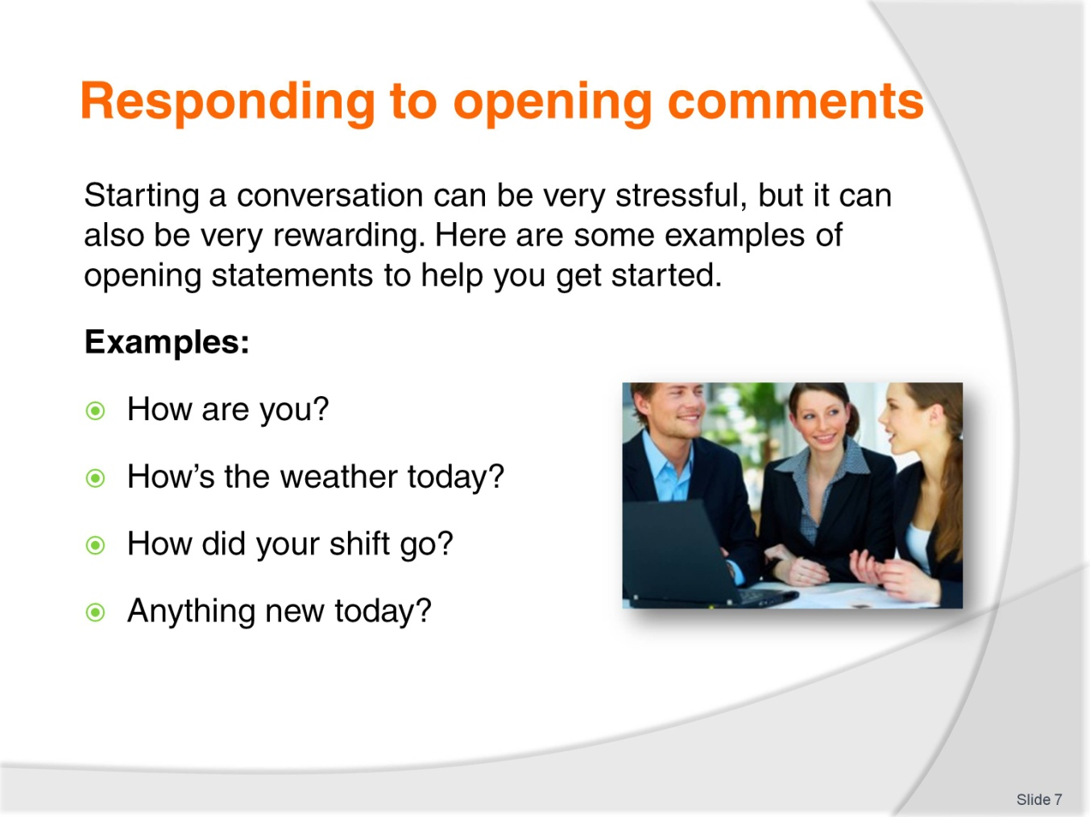
Slide No | Trainer Notes
Trainer tells students that starting a conversation can be stressful, but it can also be very rewarding. Trainer asks students why starting a conversation can be rewarding. Trainer explains that being a good conversation starter is a skill. Trainer asks students how this is an important skill at work and in their personal lives.
Trainer explains that opening statements help to start a conversation and gives some examples:
How are you?
How’s the weather today?
How did your shift go?
Anything new today?
Trainer asks students if they can think of any more examples of opening statements. Trainer writes these examples on the board.

Slide
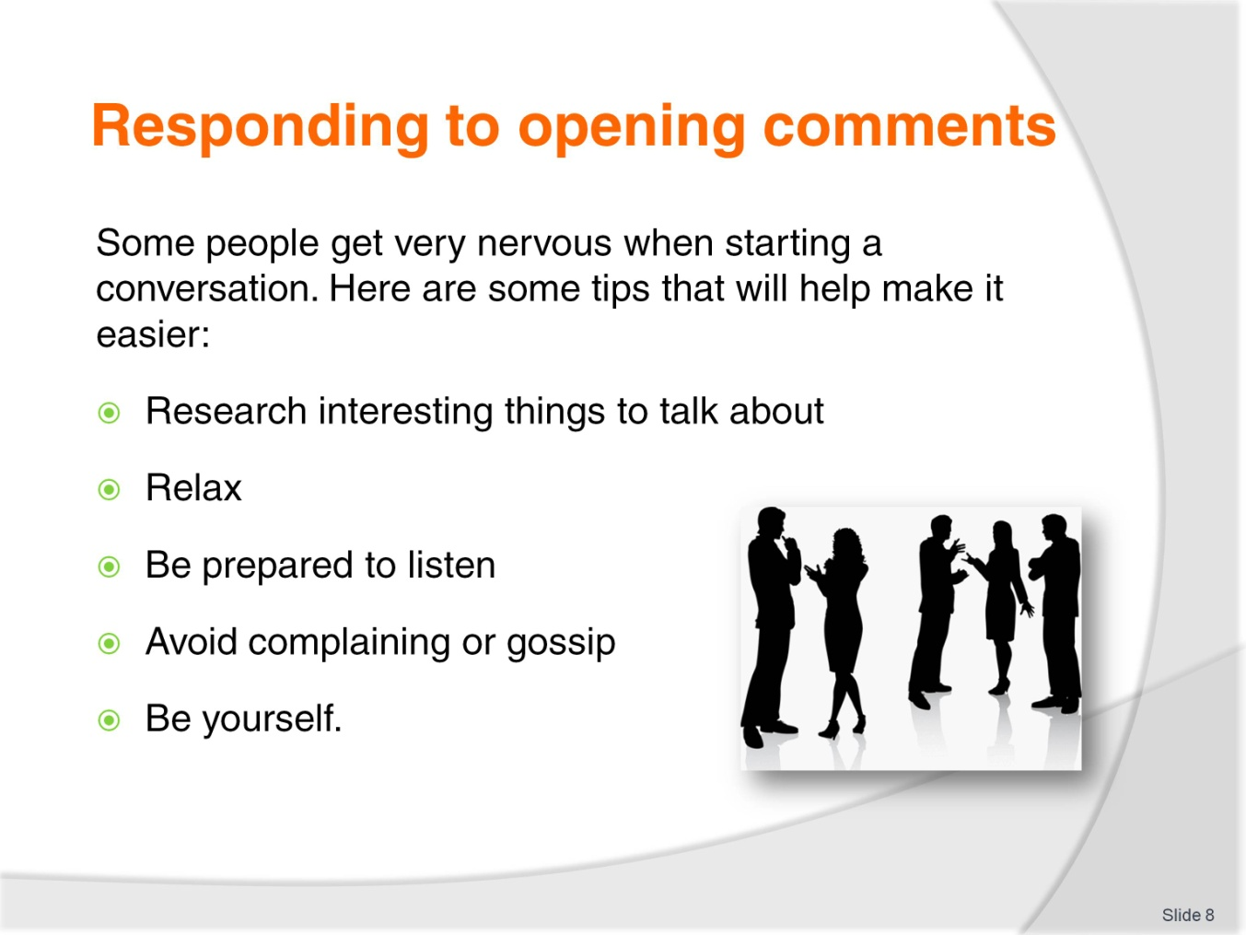
Slide No | Trainer Notes
Trainer acknowledges that starting conversations can make some people very nervous. Trainer explains that people in the hospitality industry must get over this fear. Trainer offers tips that can help them:
Research interesting things to say
Relax
Avoid complaining or gossip
Be yourself.

Slide
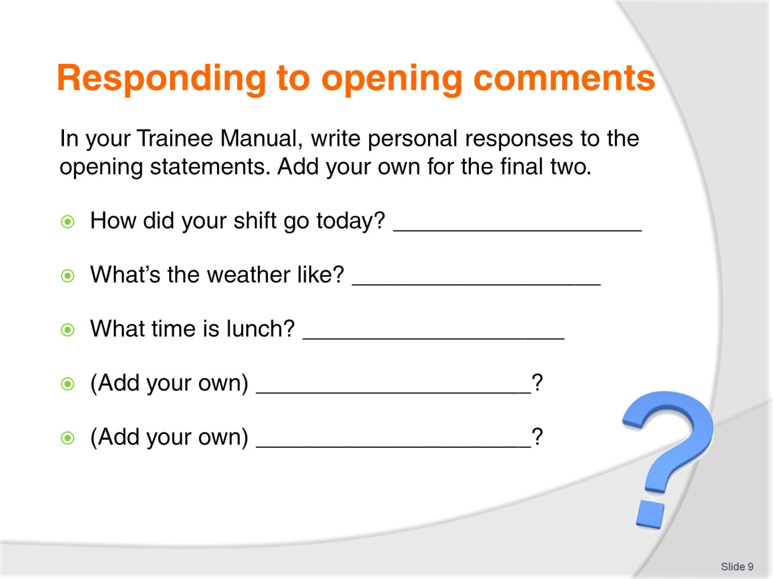
Slide No | Trainer Notes
Class Activity - Individual
Trainer instructs students to write responses to the opening questions in their Trainee Manual. Students must also create two new opening statements and answer them.
Class Activity – Pair work
Students should practice asking these questions to a partner. When they are finished, they should swap roles.

Slide
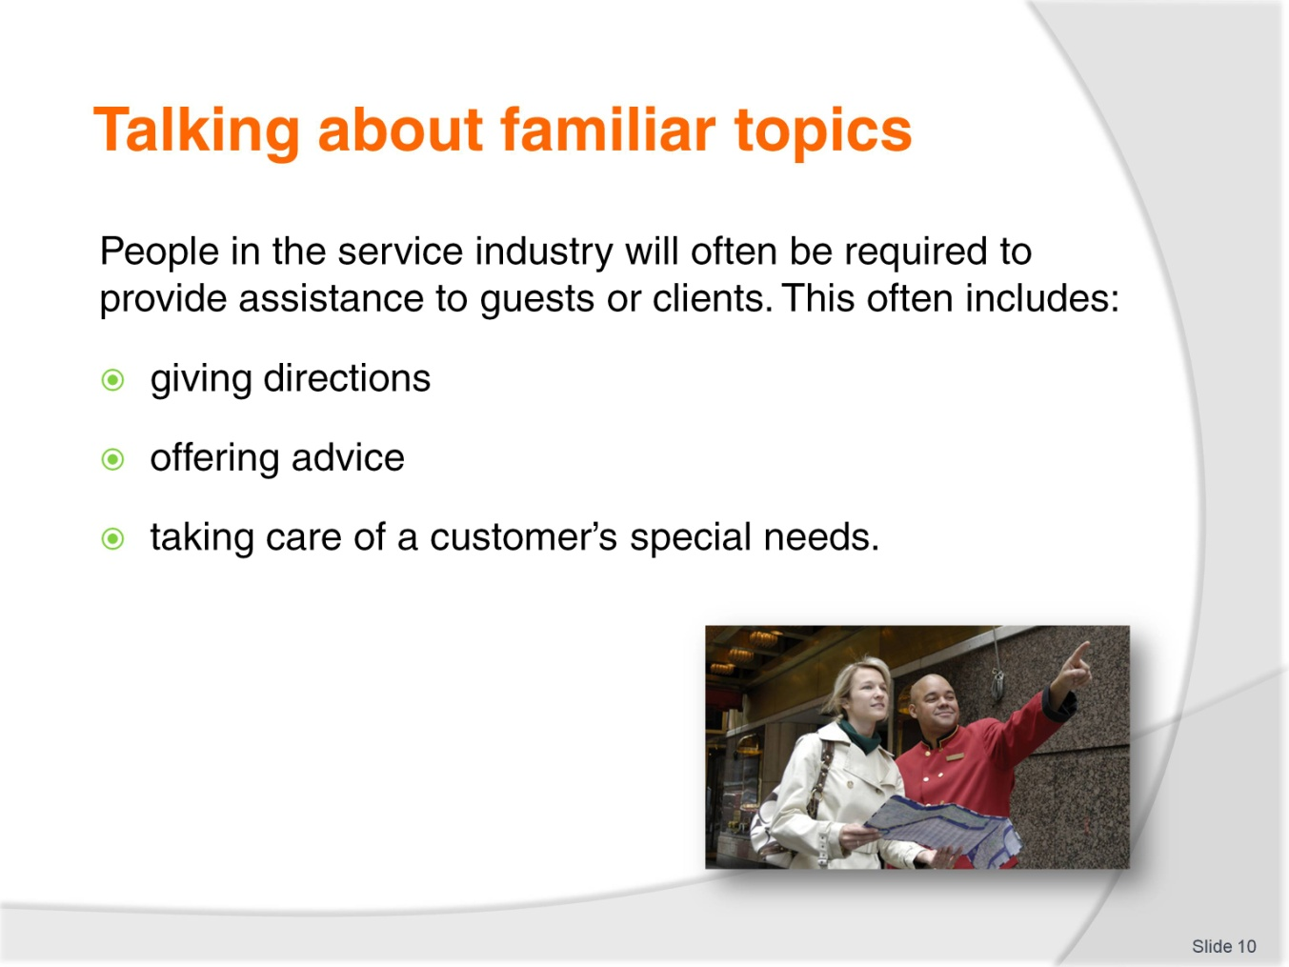
Slide No | Trainer Notes
Trainer explains that employees in the service industry will often be required to provide assistance to customers. This includes:
Giving directions
Offering advice
Taking care of a customer’s special needs.

Slide
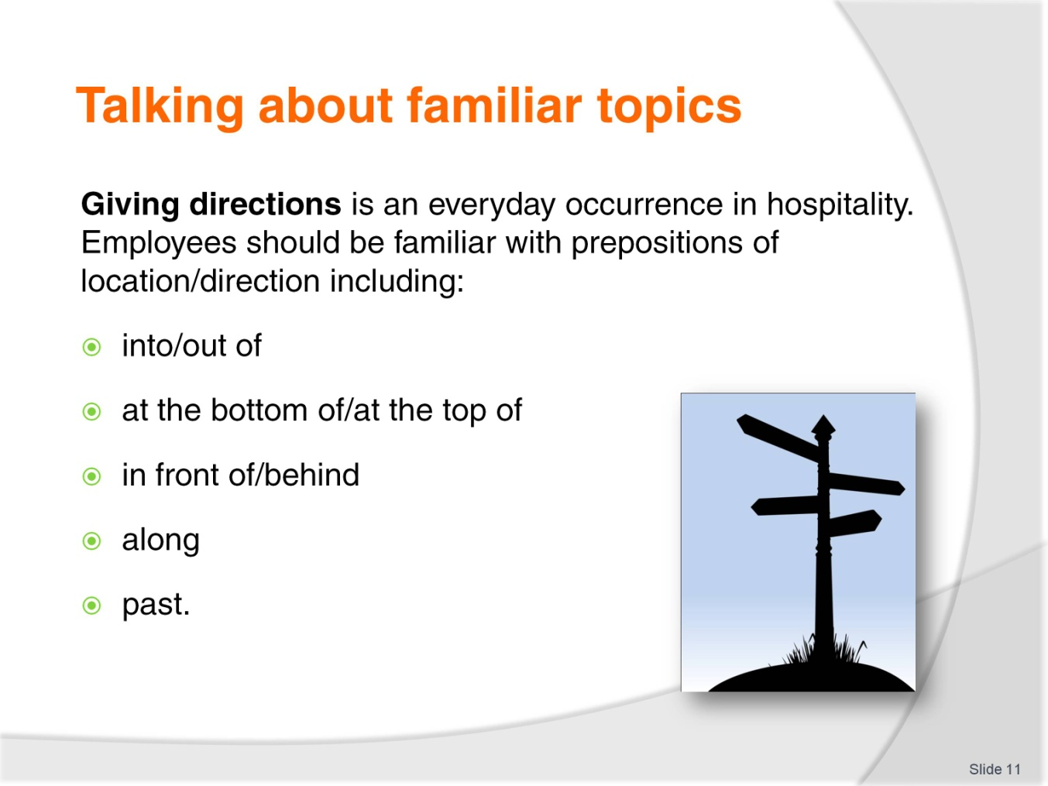
Slide No | Trainer Notes
Trainer explains that giving directions will be a big part of the students’ jobs. Trainer tells students that they should be familiar with prepositions of location/direction including:
Into/out of
At the bottom of/at the top of
In front of/behind
Along
Past.
Trainer asks students if they can think of any other words they use to give directions. Trainer instructs students to complete the prepositions of location/direction activity in their Trainee Manual.

Slide
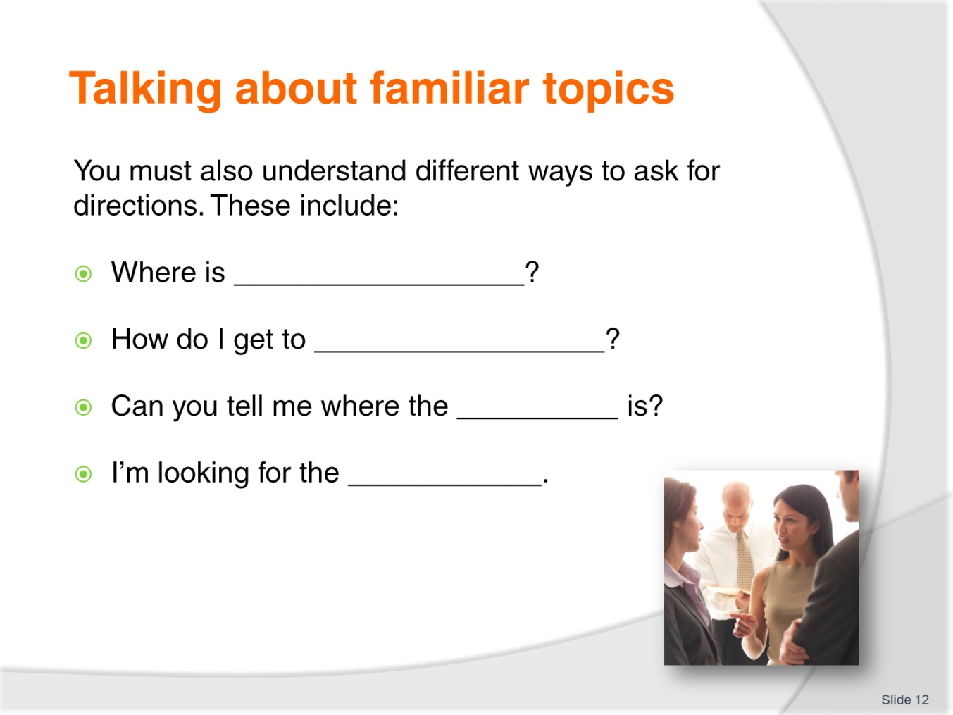
Slide No | Trainer Notes
Trainer tells students that they must first understand when someone is asking for directions in order to respond appropriately. Examples of ways to ask for directions include:
Where is _________?
How do I get to ____________?
Can you tell me where the ___________ is?
I’m looking for the _____________.
Class Activity – Pair work
Trainer instructs students to work in pairs to ask directions to 5 places in their workplace.

Slide
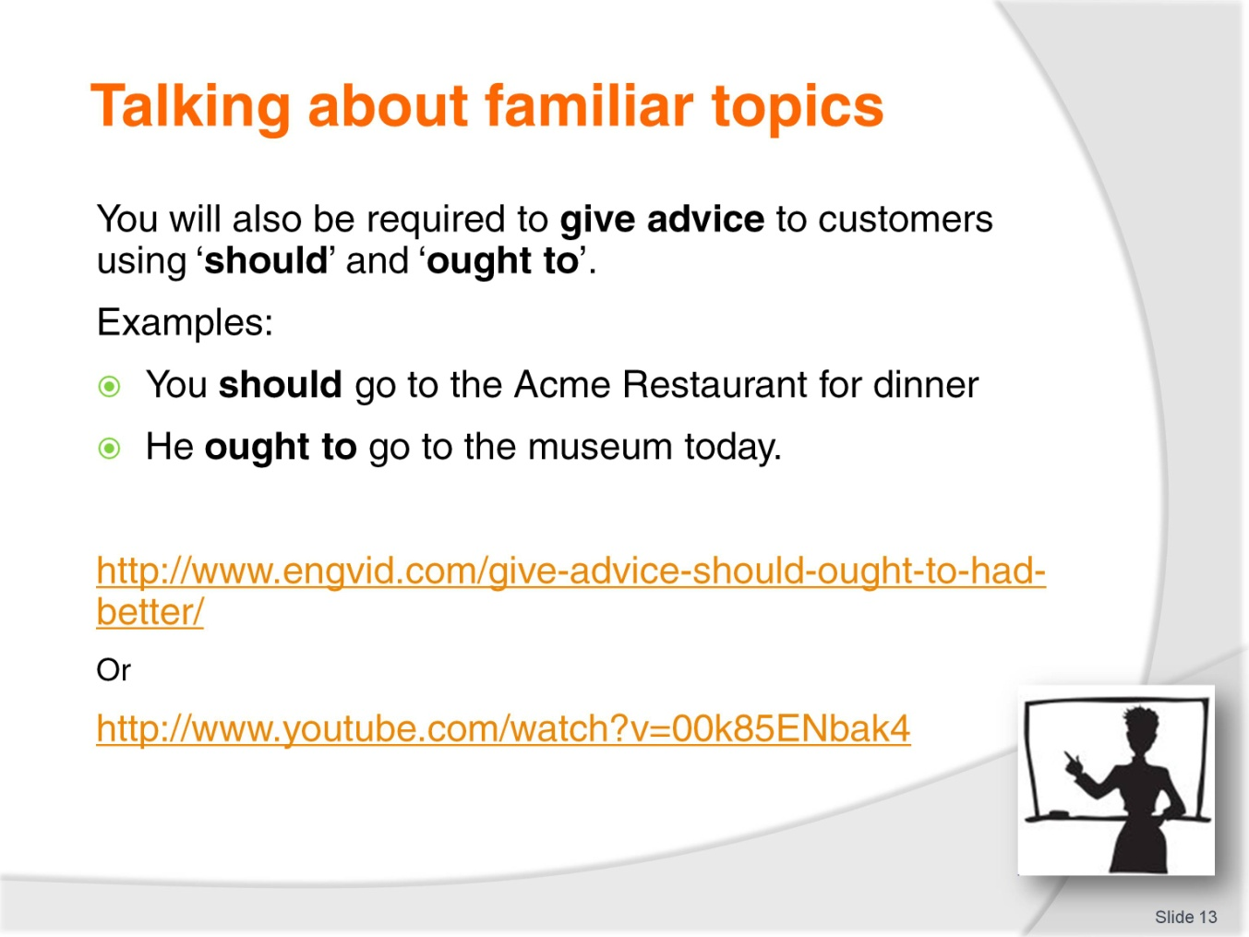
Slide No | Trainer Notes
Trainer explains that students will also be responsible for giving advice to customers. Trainer instructs students to give advice using:
Should
Ought to.
Class Activity
Trainer instructs students to give advice to two other students in the class
Trainer uses video at:
http://www.engvid.com/give-advice-should-ought-to-had-better/
or
http://www.youtube.com/watch?v=00k85ENbak4

Slide
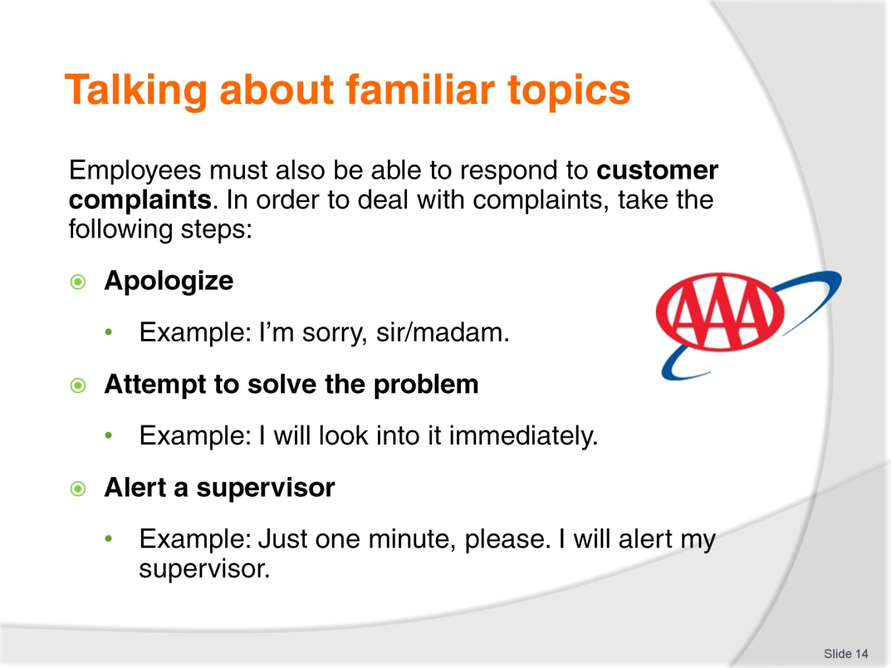
Slide No | Trainer Notes
Trainer will outline the following steps to deal with customer complaints:
Apologize
Attempt to solve the problem
Alert a supervisor.
Trainer instructs students to think of three complaints that they hear in their jobs.
Class Activity – Pair work
Trainer instructs students to work in pairs to do a roleplay with complaints.

Slide
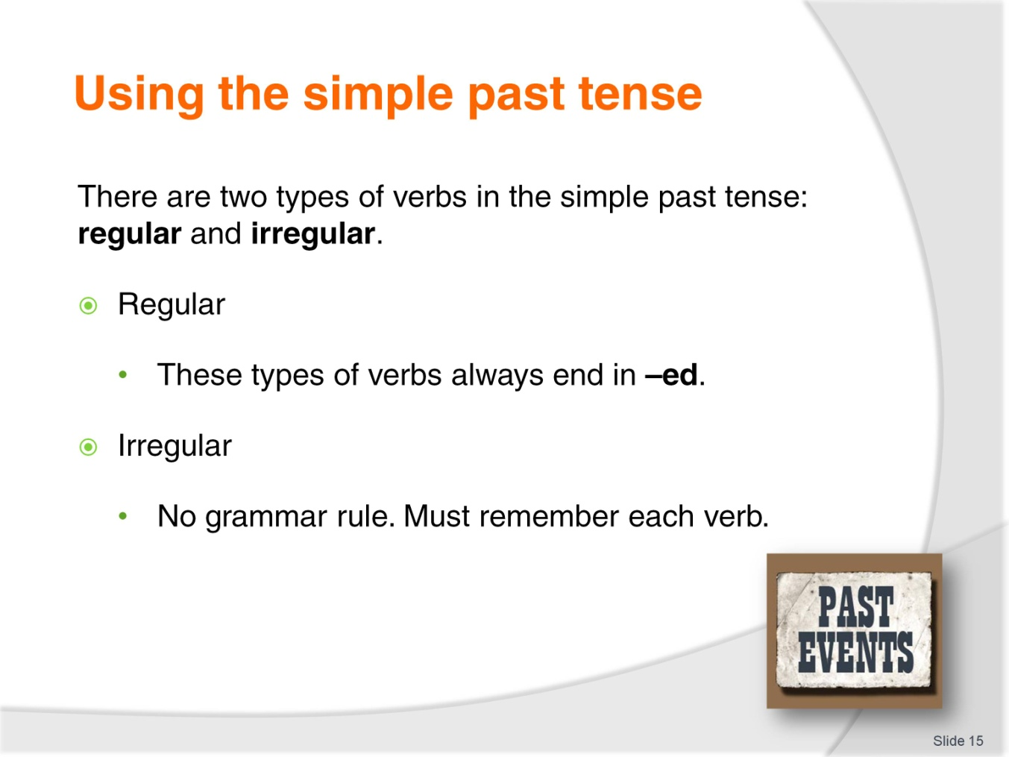
Slide No | Trainer Notes
Trainer explains the difference between regular and irregular past tense verbs.
Regular Verbs:
End in –ed.
Irregular Verbs:
Have no specific grammar rule, students must remember each of them.
Class Activity – Individual
Trainer instructs students to complete the grammar exercise in their Trainee Manual.

Slide
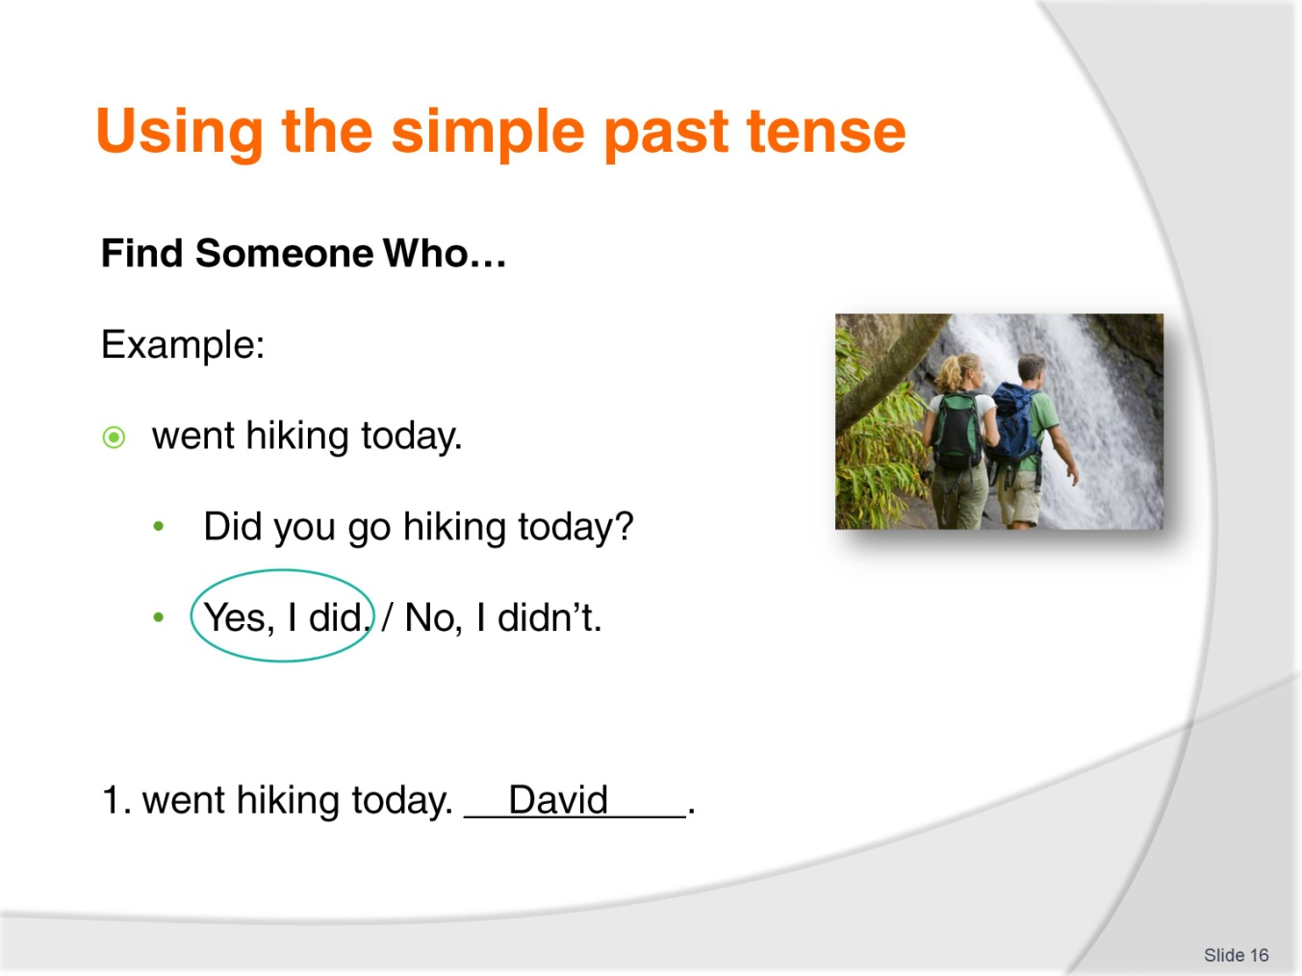
Slide No | Trainer Notes
Class Activity – Mingling
Trainer explains the rules to Find Someone Who.
Students must mingle with their classmates to find out what people did in the past. Students should ask questions to each other, and write down one name for every positive answer. Students should not right down a name for negative answers. They should only write down the same name twice (depending on the number of students).

Slide
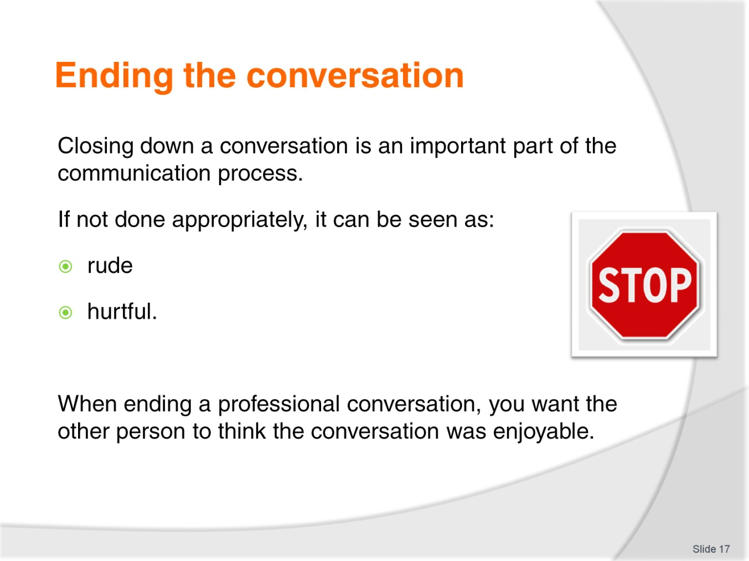
Slide No | Trainer Notes
Trainer describes the importance of ending conversations. If not done appropriately, it can be seen as:
Rude
Hurtful.
Trainer tells students that they should make the other person feel as if the conversation was enjoyable.

Slide
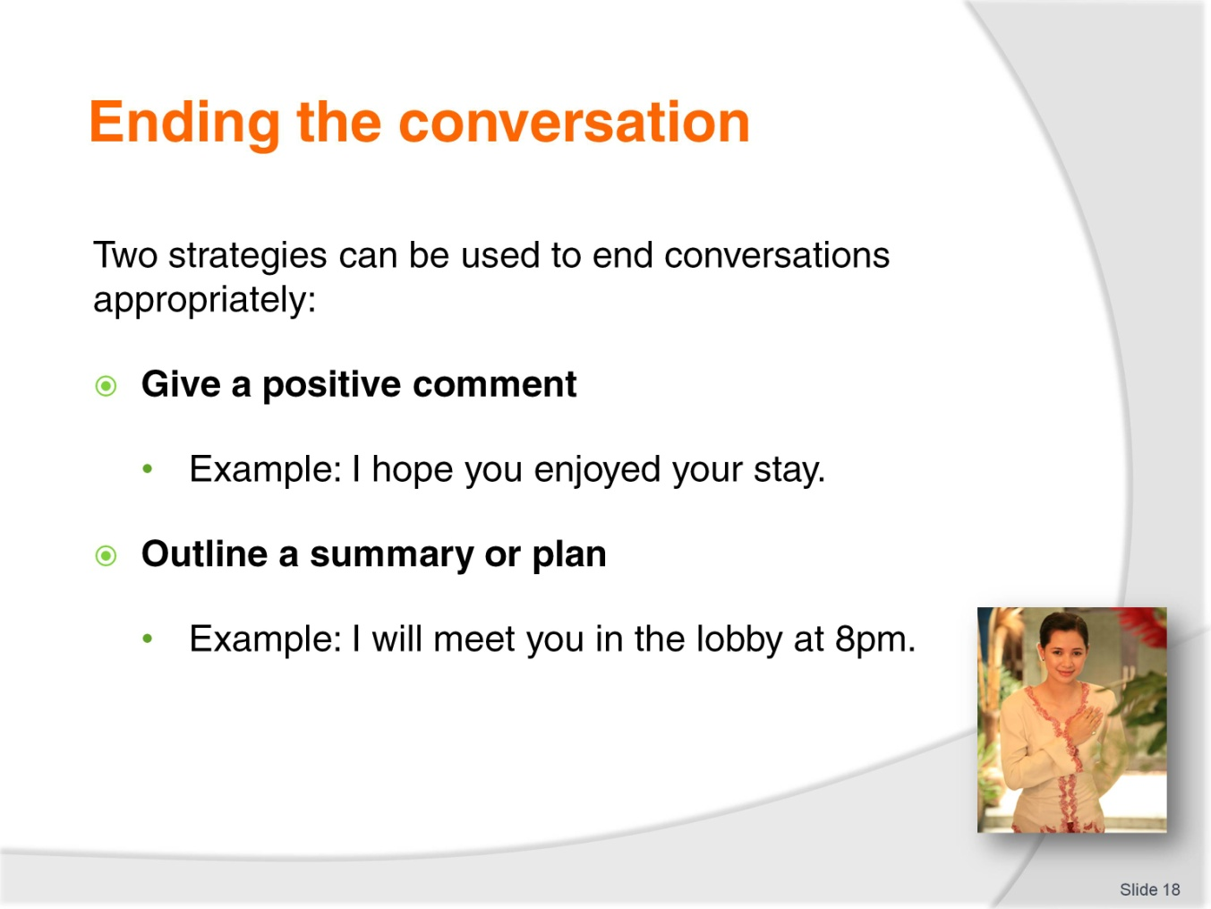
Slide No | Trainer Notes
Trainer outlines two strategies for ending conversations appropriately. These include:
Giving a positive comment.
Outlining a summary or plan.
Class Activity – Pair work
Trainer instructs students to complete the exercise in their Trainee Manual and read the dialogues in pairs.

Slide
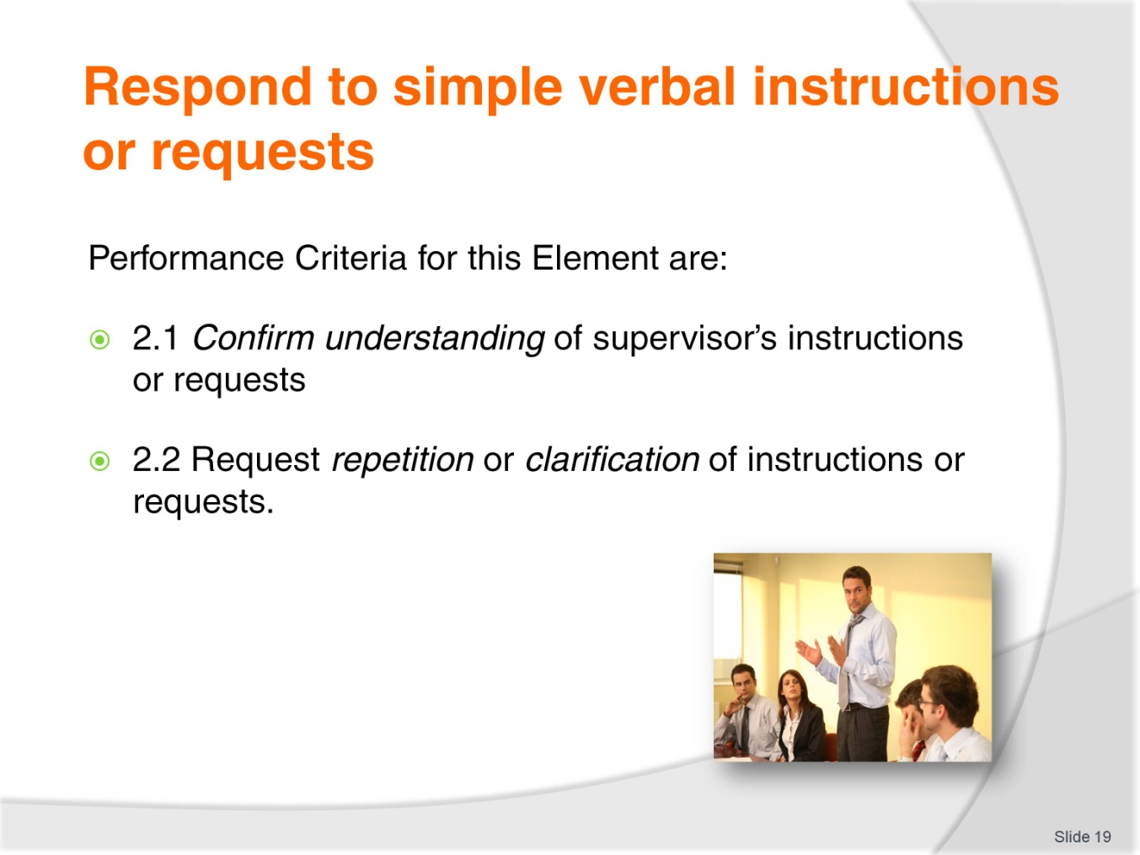
Slide No | Trainer Notes
Trainer identifies the Performance Criteria for this Element, as listed on the slide.
Class Activity – General discussion
Trainer leads a general class discussion on responding to instructions and requests, asking questions such as:
What does ‘instructions’ mean?
What kind of requests do you get at your job?
Is it always easy to understand instructions?
What is the last request you heard at your job?
What do you do if you can’t understand what your supervisor tells you?

Slide
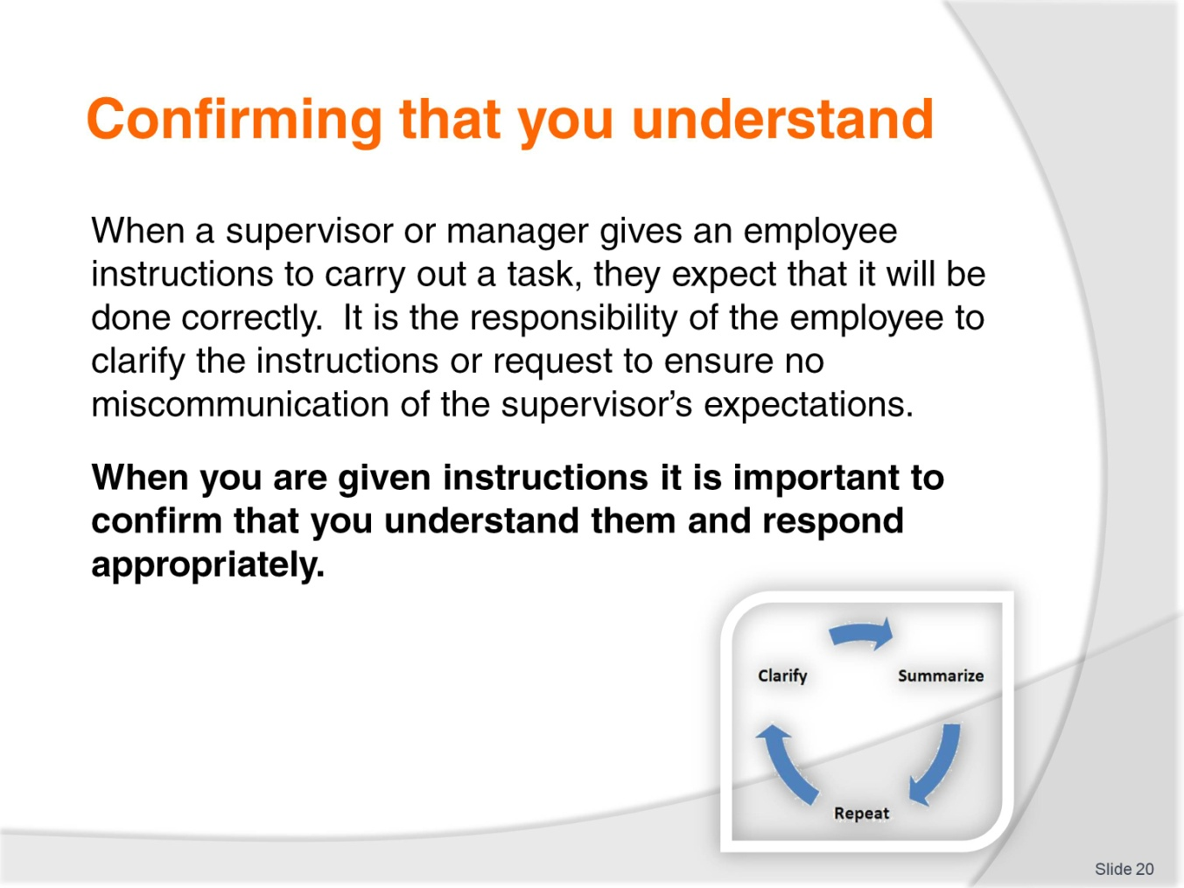
Slide No | Trainer Notes
 | Trainer describes the importance of fully comprehending instructions or requests, as outlined on the slide. Trainer emphasizes the importance of confirming full comprehension and responding appropriately.

Slide
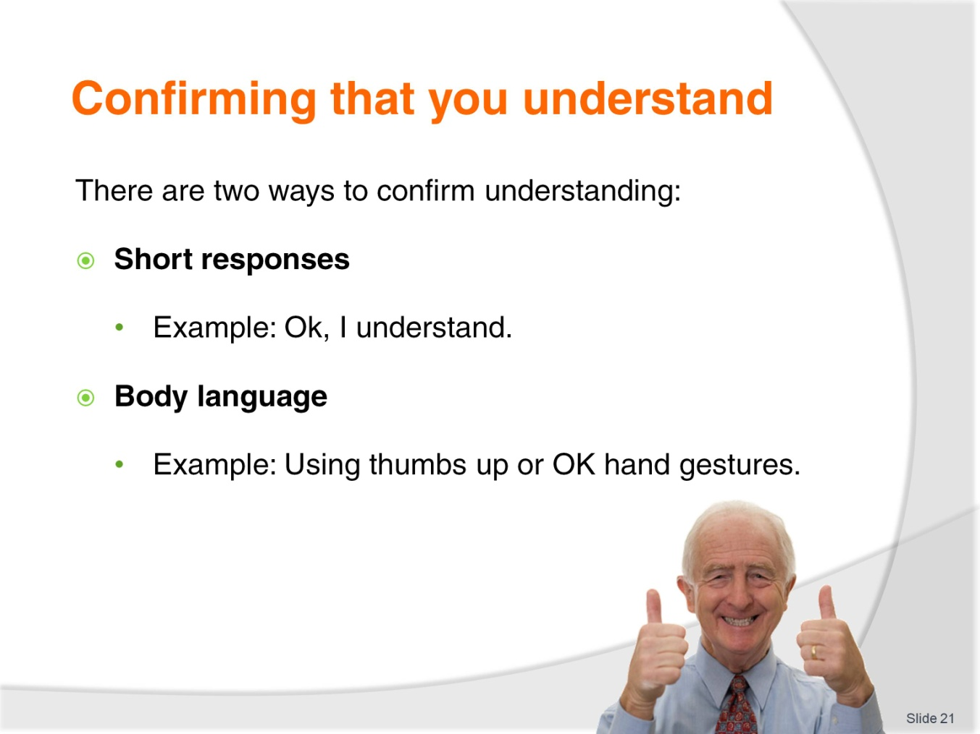
Slide No | Trainer Notes
Trainer describes two strategies to confirm understanding.
Short responses
Body language.
Trainer provides examples of each and asks the students if they can think of any more.
Trainer instructs students to guess the meaning of the physical gestures in their Trainee Manual.
Class Activity - Gestures
Trainer makes four gestures (shake head, thumbs up, palms up, ok sign) and instructs students to write the meaning of the gestures in the Trainee Manual.
Class Activity - Listening
Trainer reads the instructions below and instructs students to write the instructions in the Trainee Manual.
- Stand up and raise your hand
- Write your name on a piece of paper
- Touch your right foot
- Point your finger at the Trainer
- Walk to the door and come back to your seat
- Don’t forget to finish your homework.
Trainer then instructs students to work in pairs to give each other these instructions and confirm understanding.
Slide
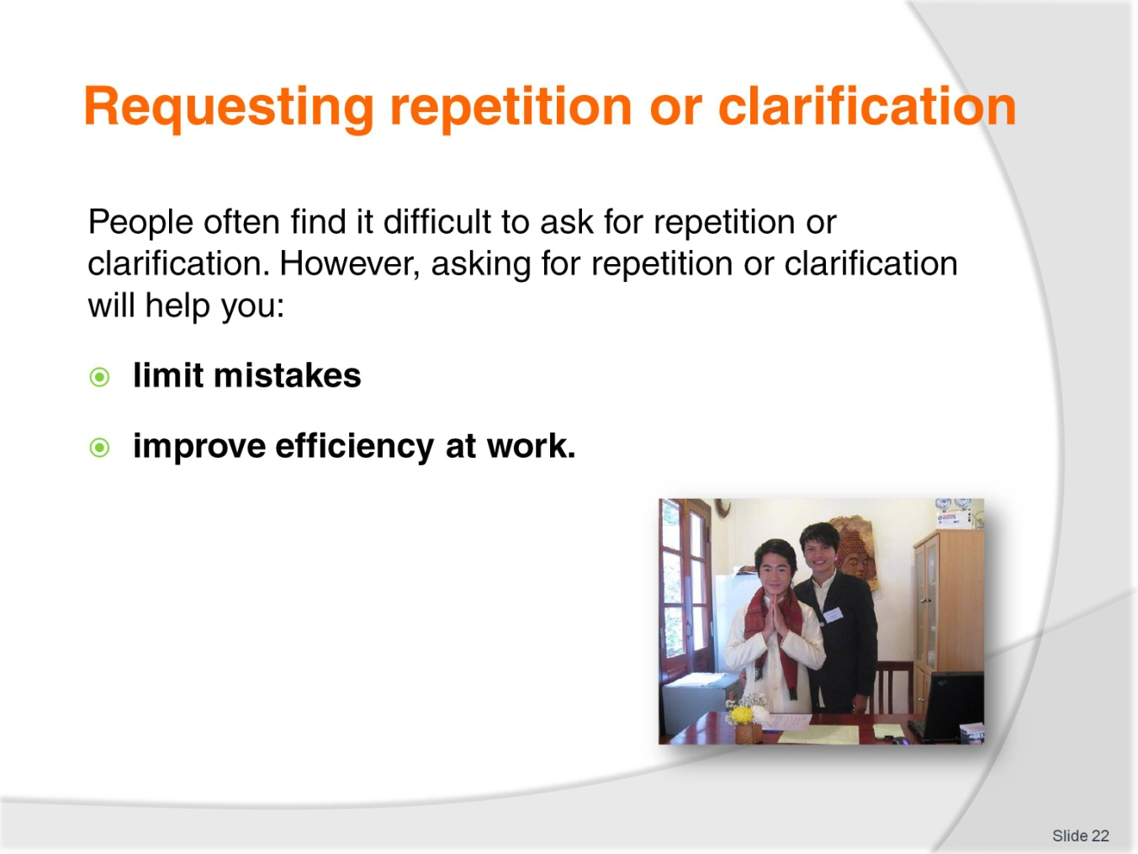
Slide No | Trainer Notes
Trainer introduces this subject by giving students fast, complicated instructions to do something in the class. Trainer observes the students’ reaction and makes a note of students that ask him/her to repeat or clarify his instructions.
Trainer tells students that people often find it difficult to ask for repetition or clarification, and that this is considered a sign of incompetence in many cultures. Trainer emphasizes the importance of asking for repetition/clarification and states that it will:
Limit mistakes at work
Improve efficiency at work.

Slide
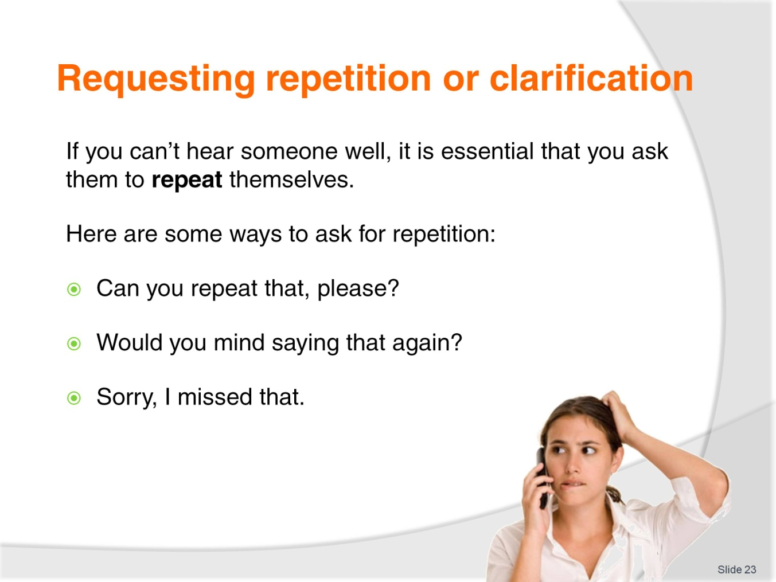
Slide No | Trainer Notes
Trainer instructs students to ask for repetition when they don’t hear the speaker well.
Trainer provides examples including:
Can you repeat that, please?
Would you mind saying that again?
Sorry, I missed that.
Trainer asks the students to think of additional ways to ask for repetition.

Slide
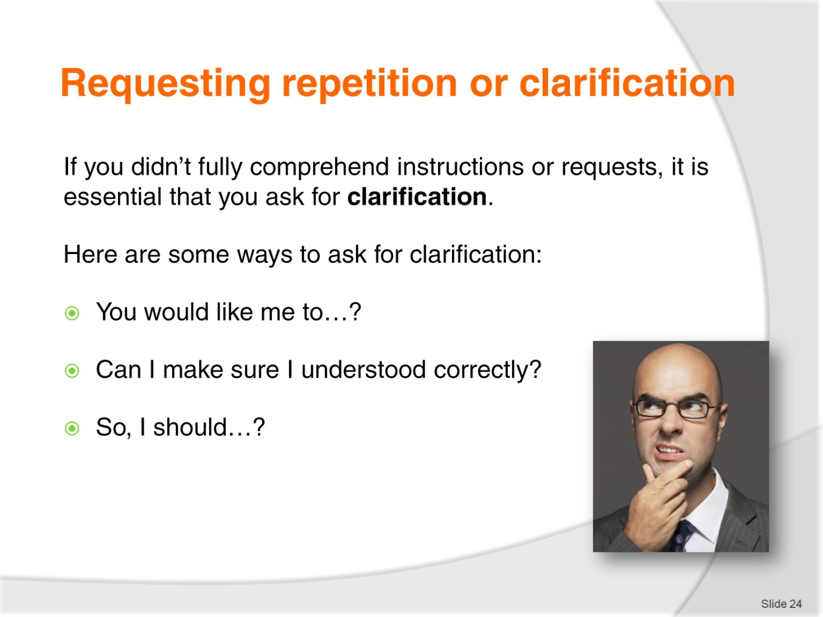
Slide No | Trainer Notes
Trainer instructs the students to ask for clarification when they don’t completely understand the instructions.
Trainer provides examples including:
So, you would like me to…?
Can I make sure I understood that correctly?
So, I should…?
Trainer asks the students to think of additional ways to ask for clarification.

Slide
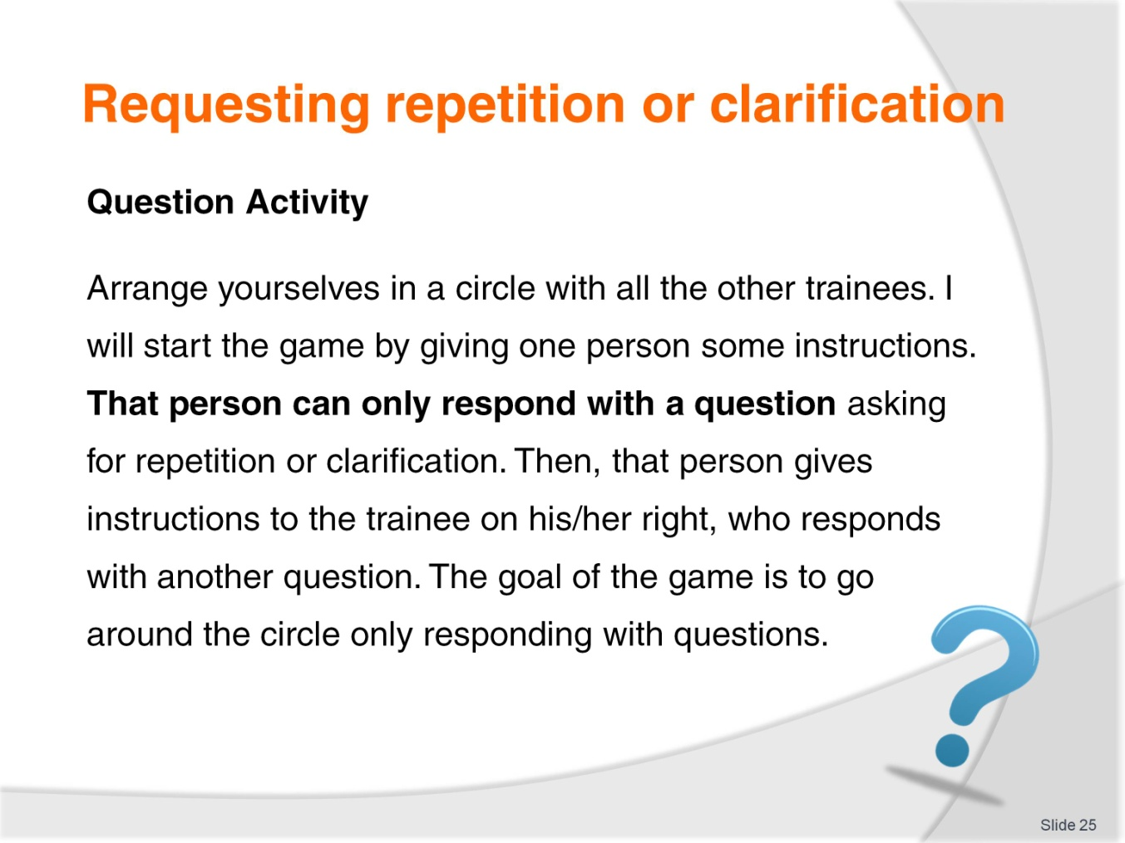
Slide No | Trainer Notes
Class Activity
Trainer describes the rules of the Question Game, as outlined on the slide.

Slide
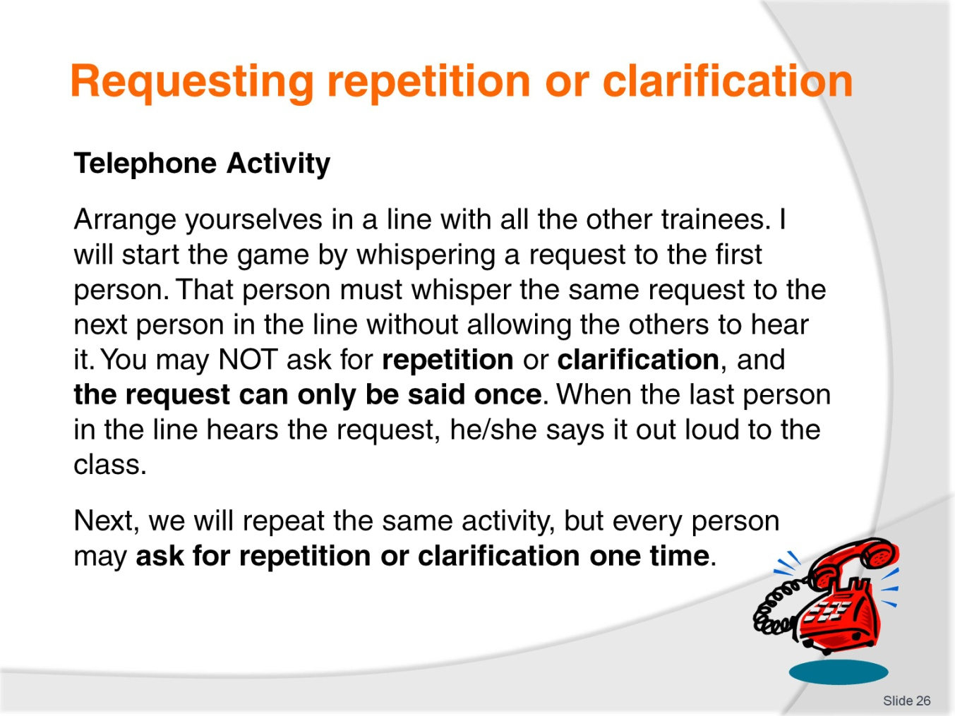
Slide No | Trainer Notes
Class Activity
Trainer describes the rules of the Telephone Game, as outlined on the slide.

Slide
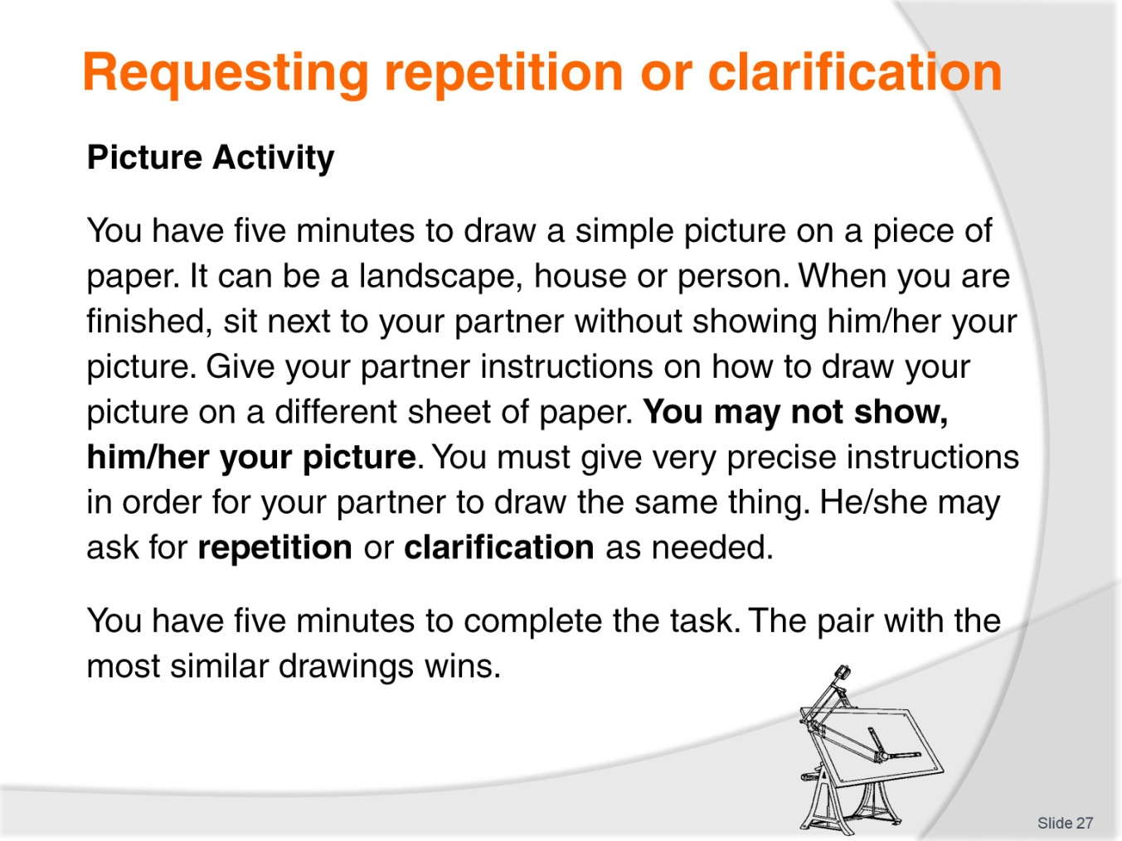
Slide No | Trainer Notes
Class Activity
Trainer describes the rules of the Picture Game, as outlined on the slide.

Slide
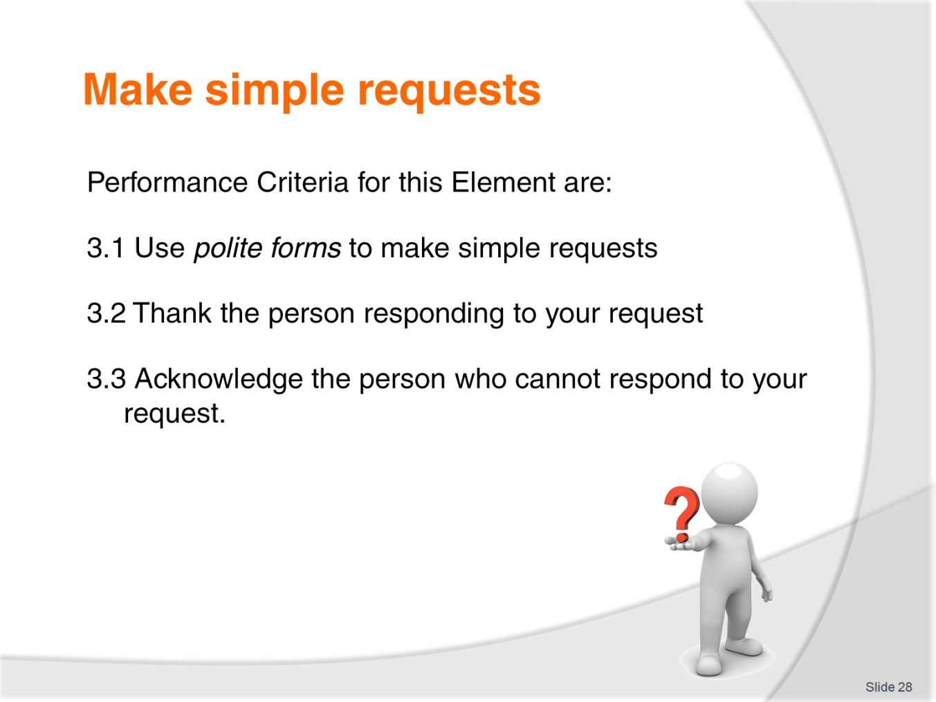
Slide No | Trainer Notes
Trainer identifies the Performance Criteria for this Element, as listed on the slide.
Class Activity – General discussion
Trainer leads a general class discussion on making requests at work, asking questions such as:
Do you ever make requests to your customers?
What kinds of things do you ask them for?
What is the difference between ‘rude’ and ‘polite’?
What are some polite ways to ask for things?
How can you help guests that don’t speak your language or English?

Slide
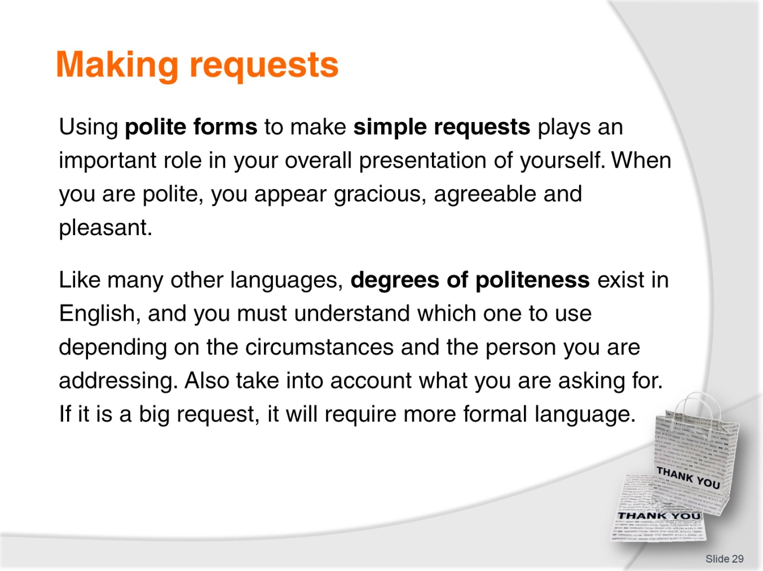
Slide No | Trainer Notes
Trainer emphasizes the importance of making polite requests in English, telling the students it can make them seem:
Gracious
Agreeable
Pleasant.
Trainer asks students if there is a degree of politeness in their language. Trainer explains that one exists in English and pay attention to the following criteria in order to determine which structure to use:
Circumstances
Status of person
Kind of request being asked.

Slide
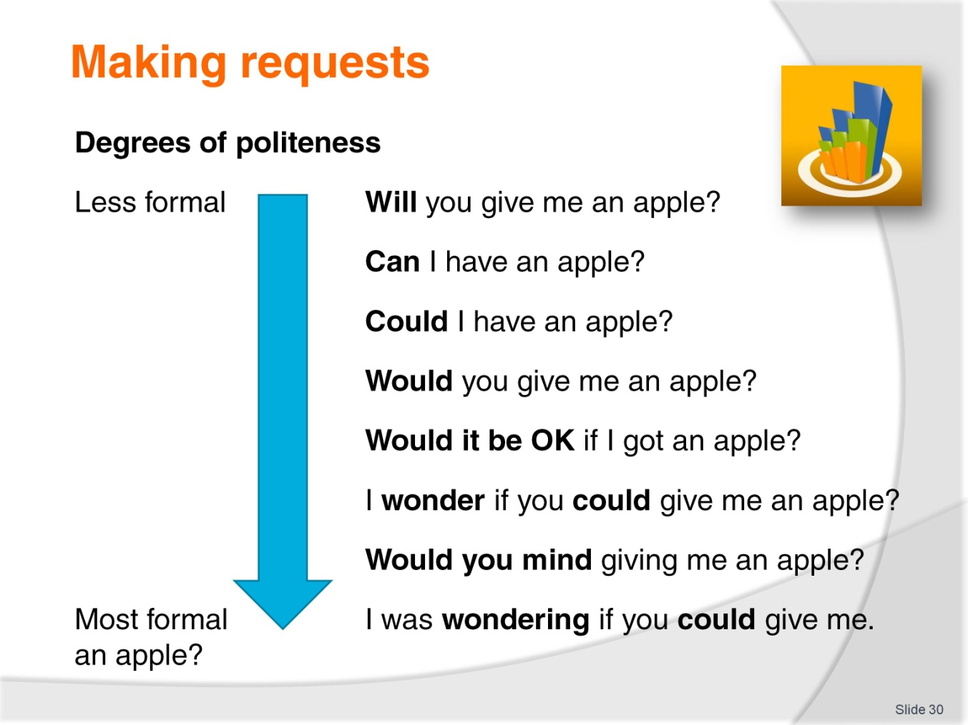
Slide No | Trainer Notes
 | Discuss the degrees of politeness above and practice them in pairs. In which circumstances and with whom are the different phrases likely to be used?

Slide
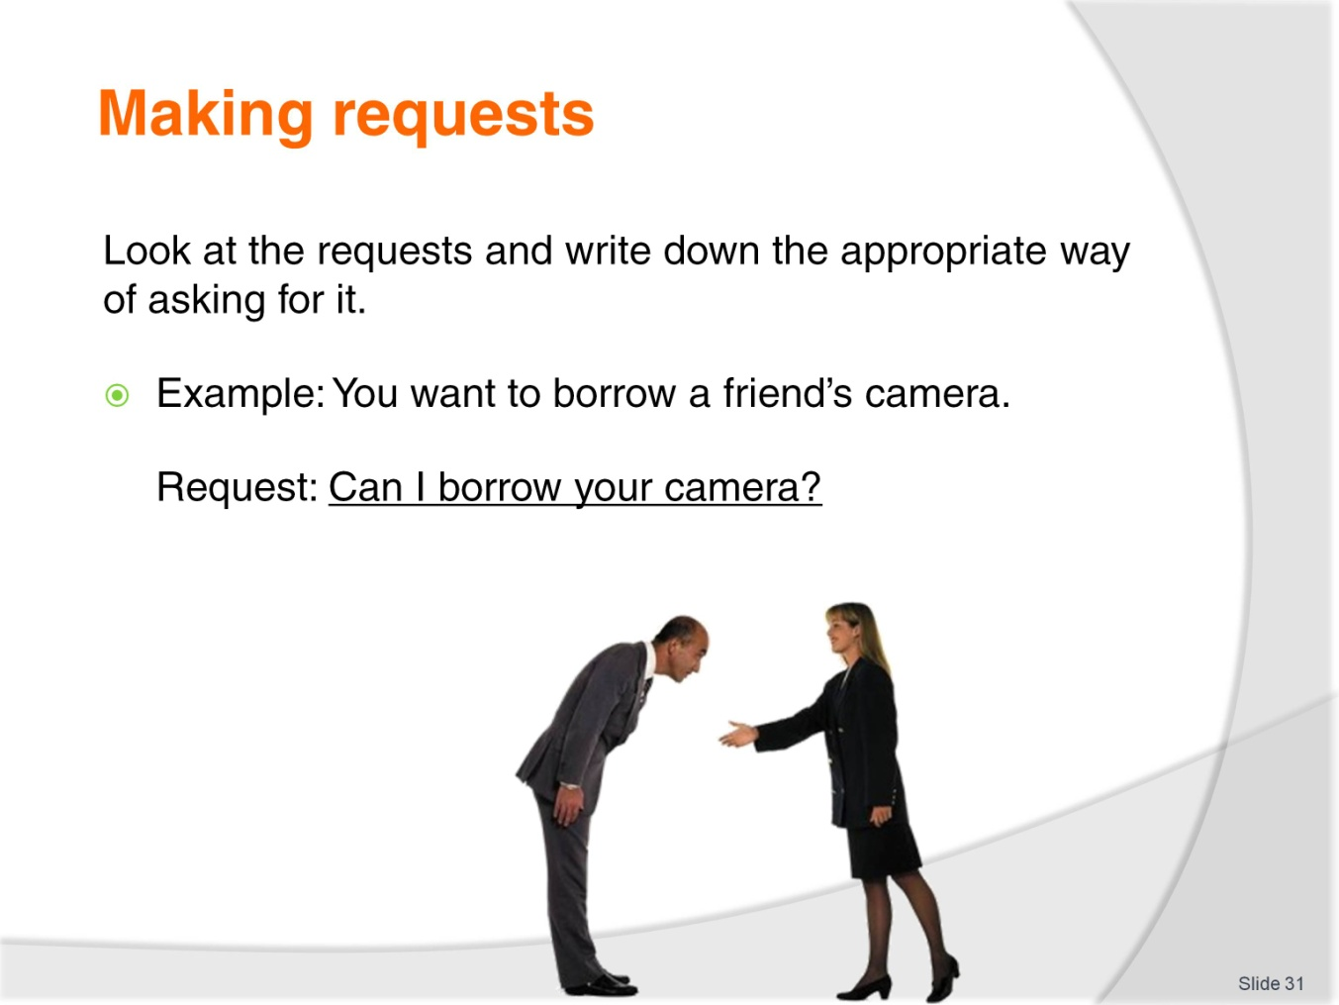
Slide No | Trainer Notes
Class Activity - Dialogues
Trainer instructs the students to read the dialogues in their Trainee Manual, circle the requests, and decide if they are formal or informal. Trainer then instructs students to work in pairs in order to do role plays with the dialogues.
Class Activity
Trainer instructs students to write the proper requests in their Trainee Manual. Trainer then instructs students to make one new formal and informal request to other trainees in the class.

Slide

Slide No | Trainer Notes
Trainer expresses the importance of showing gratitude in English, noting:
When you express gratitude you evoke feelings of warmth and solidarity
When you fail to express gratitude it can result in negative feelings and consequences.

Slide

Slide No | Trainer Notes
Trainer explains that there are many ways to say ‘Thank You’ in English, noting that the appropriate way depends on the situation.
Thanks
Thanks a lot
Thank you very much
I appreciate that.
Trainer asks if students can think of any additional ways to say ‘Thank You’.
Trainer shows video.

Slide
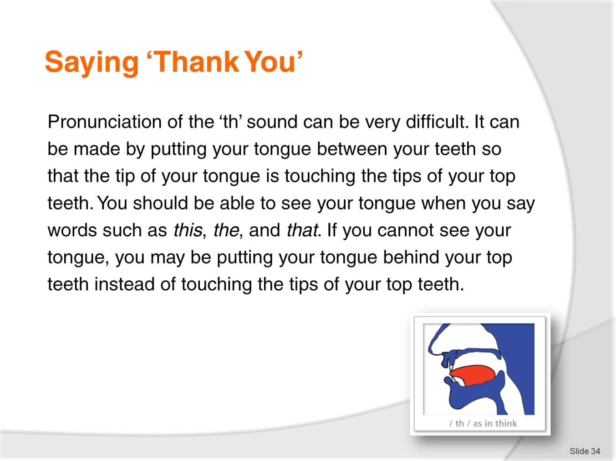
Slide No | Trainer Notes
Trainer conducts pronunciation exercises with the ‘th’ sound, instructing the students to touch the tip of their tongue to their top teeth in order to do it properly.
Class Activity – Individual
Trainer instructs students to write the appropriate form of gratitude next to the scenarios in their Trainee Manual.

Slide
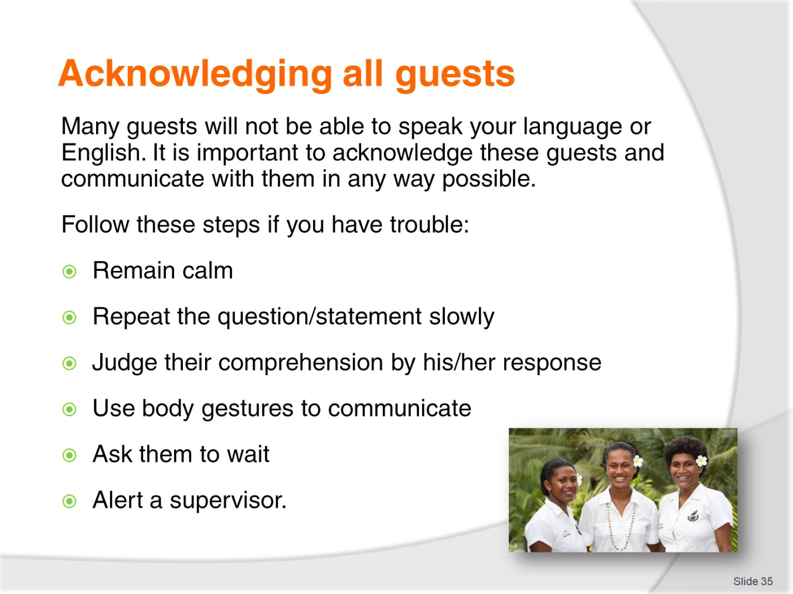
Slide No | Trainer Notes
Trainer instructs students to take the following steps if they are having problems communicating with guests:
Remain calm
Repeat the question/statement slowly
Judge comprehension
Use body gestures
Ask the guest to wait
Alert a supervisor.

Slide
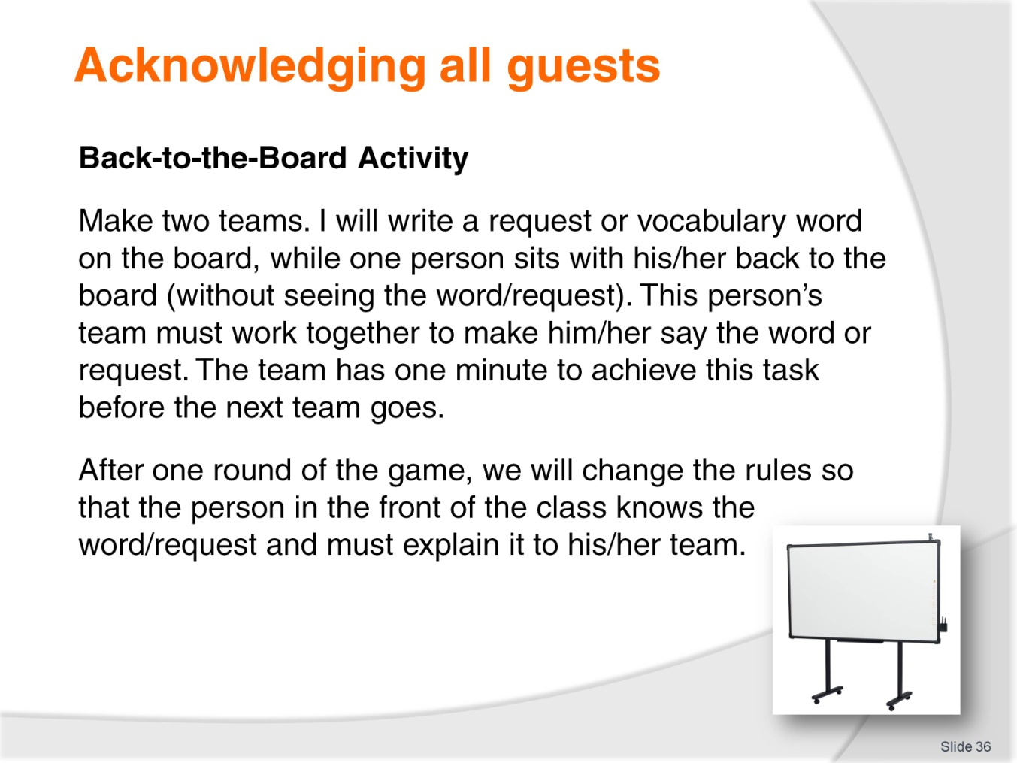
Slide No | Trainer Notes
Class Activity
Trainer describes the rules of the Back-to-the-Board Game, as outlined on the slide.

Slide
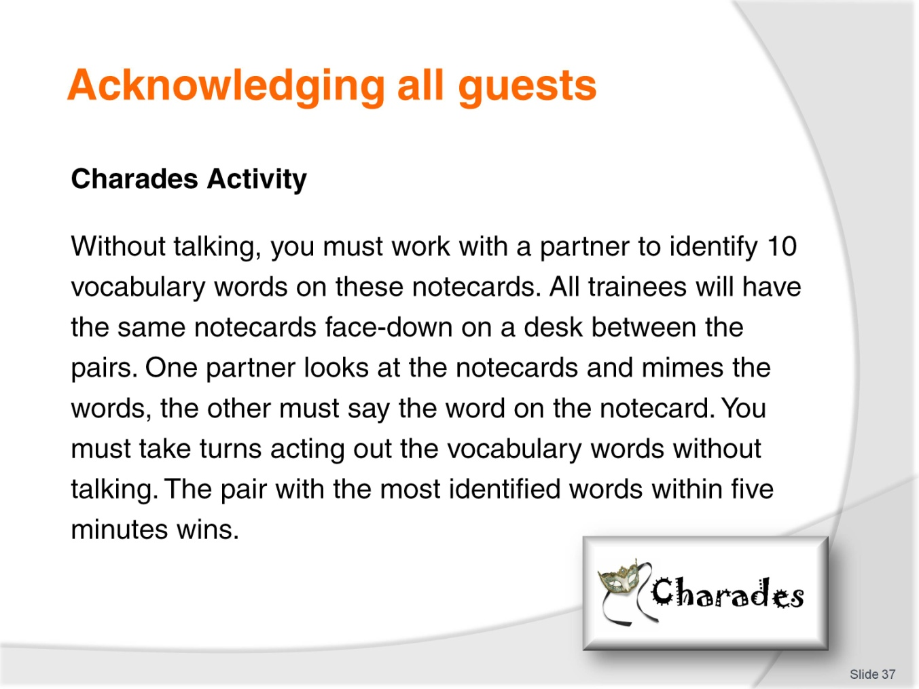
Slide No | Trainer Notes
Class Activity
Trainer describes the rules of the Charades Game, as outlined on the slide.
Trainer must prepare notecards before class.

Slide
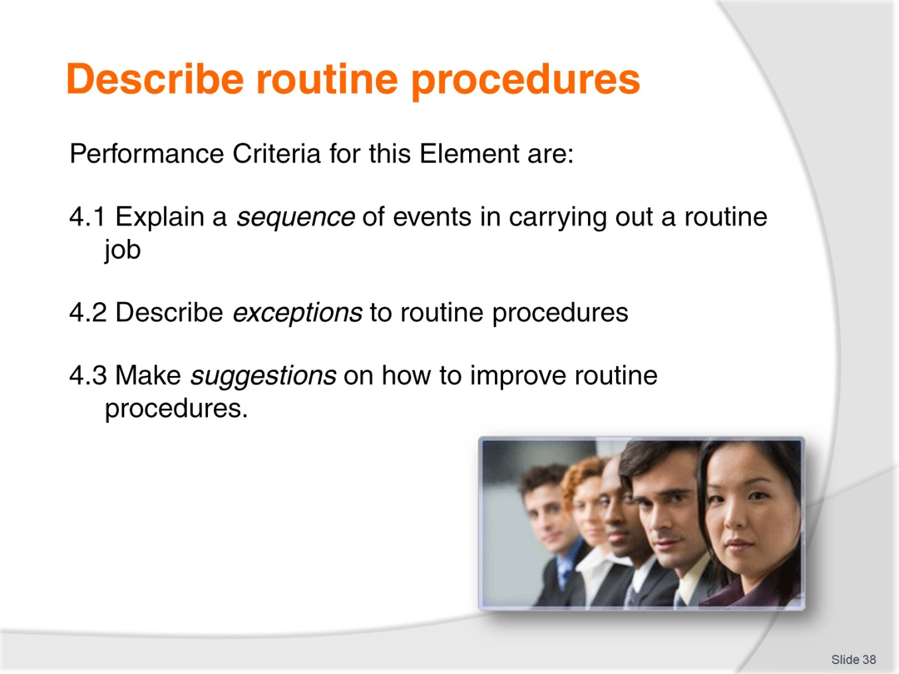
Slide No | Trainer Notes
Trainer identifies the Performance Criteria for this Element, as listed on the slide.
Class Activity – General discussion
Trainer leads a general class discussion on routine procedures, asking questions such as:
What kinds of things do you usually do at work?
Do you ever have to give instructions?
If yes, how do you organize the instructions so people can understand them?
What are adverbs of frequency? Why do we use them?
I want to eat at a nice restaurant tonight. Can you suggest somewhere to go?
Is this the same kind of suggestion you would give at work? How is it different?

Slide
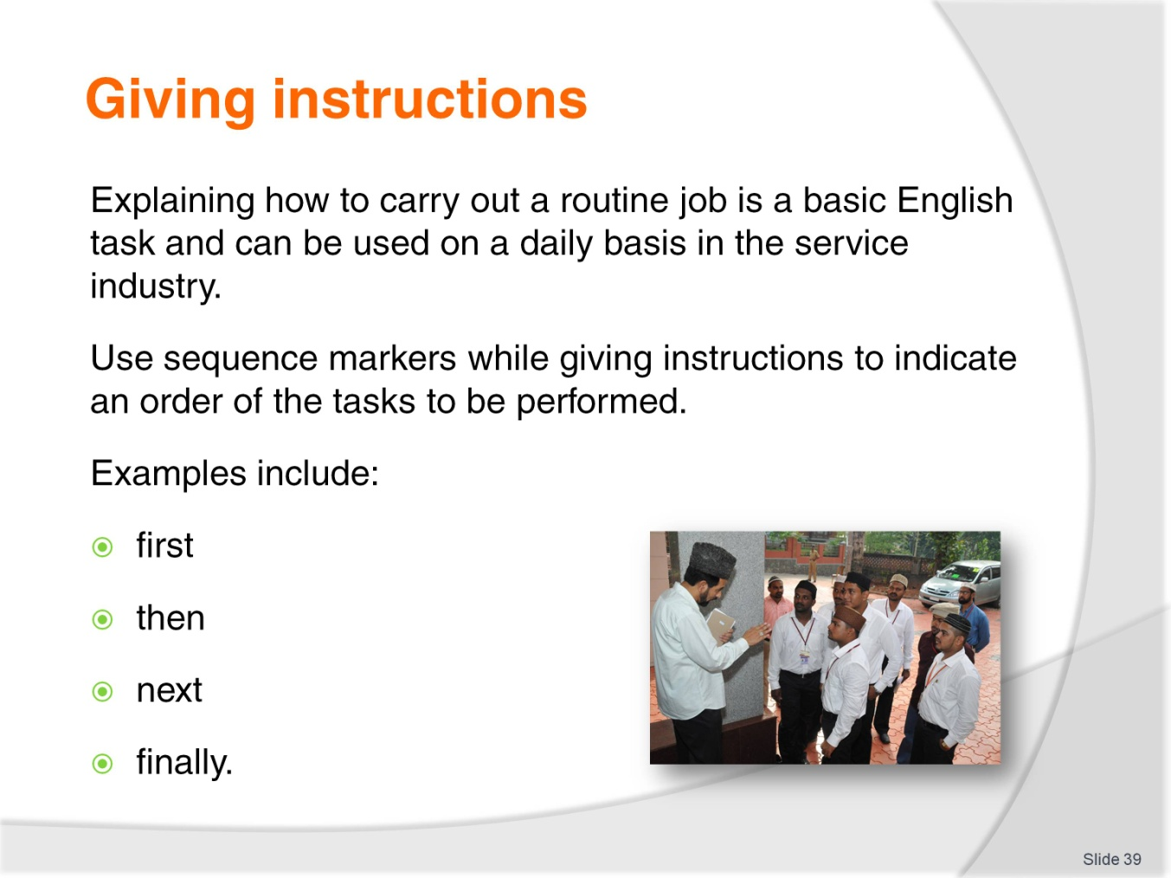
Slide No | Trainer Notes
Trainer illustrates the importance of giving clear instructions. Trainer instructs students to use sequence markers to organize their instructions. These include:
First
Then
Next
Finally.
Trainer asks students if they can think of any more examples of sequence markers.

Slide
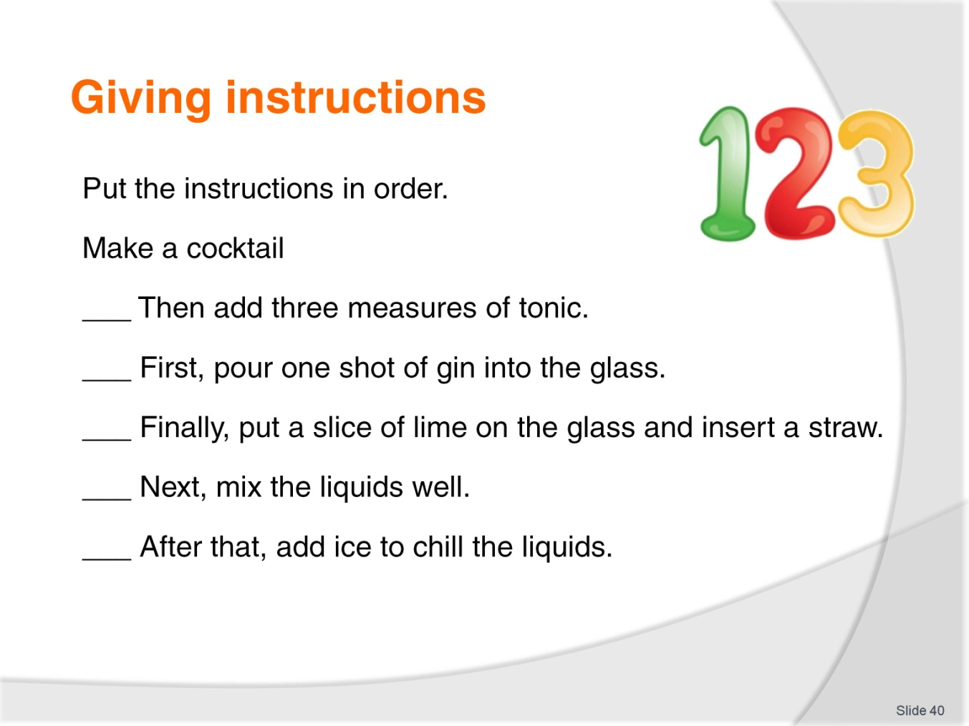
Slide No | Trainer Notes
Class Activity - Listening
Trainer instructs students to listen to his instructions (below) and put them in order in their Trainee Manual.
Make a cocktail:
First, pour one shot of gin into the glass
Then add three measures of tonic
Next, mix the liquids well
After that, add ice to chill the liquids
Finally, put a slice of lime on the glass and insert a straw.
Check-in a guest:
First, welcome the guest
Then ask for the name on the reservation
Next, check the computer system for the reservation
Then confirm the details
Ask for the guest’s credit card
Then give the guest his/her room key
Finally, ask if the guest needs help with the luggage.
Class Activity - Individual
Trainer instructs students to use sequence markers in order to write three sets of instructions in their Trainer Manual.
Class Activity - Group
Trainer instructs students to work in small groups to write instructions on how to make one kind of local food. Students will read the instructions to the class.

Slide
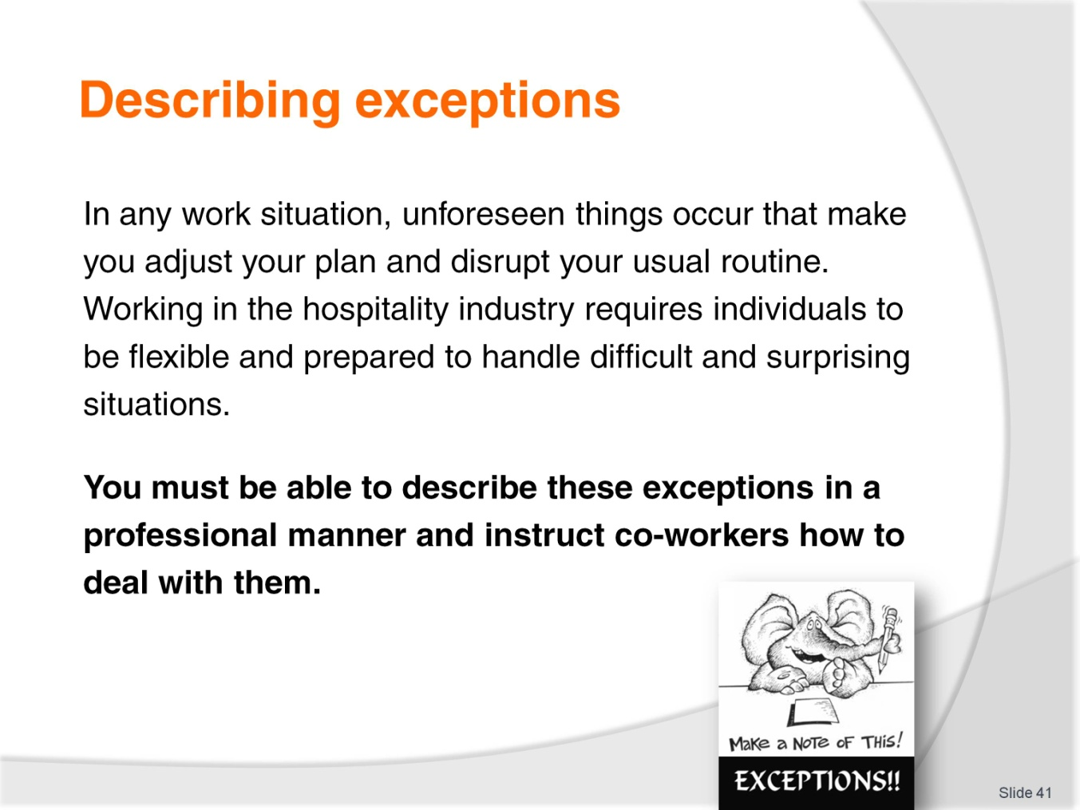
Slide No | Trainer Notes
Trainer explains that surprises often occur in the hospitality industry that force people to change their plans. Trainer stresses the importance of being able to describe these situations.
Trainer asks the class for examples.

Slide
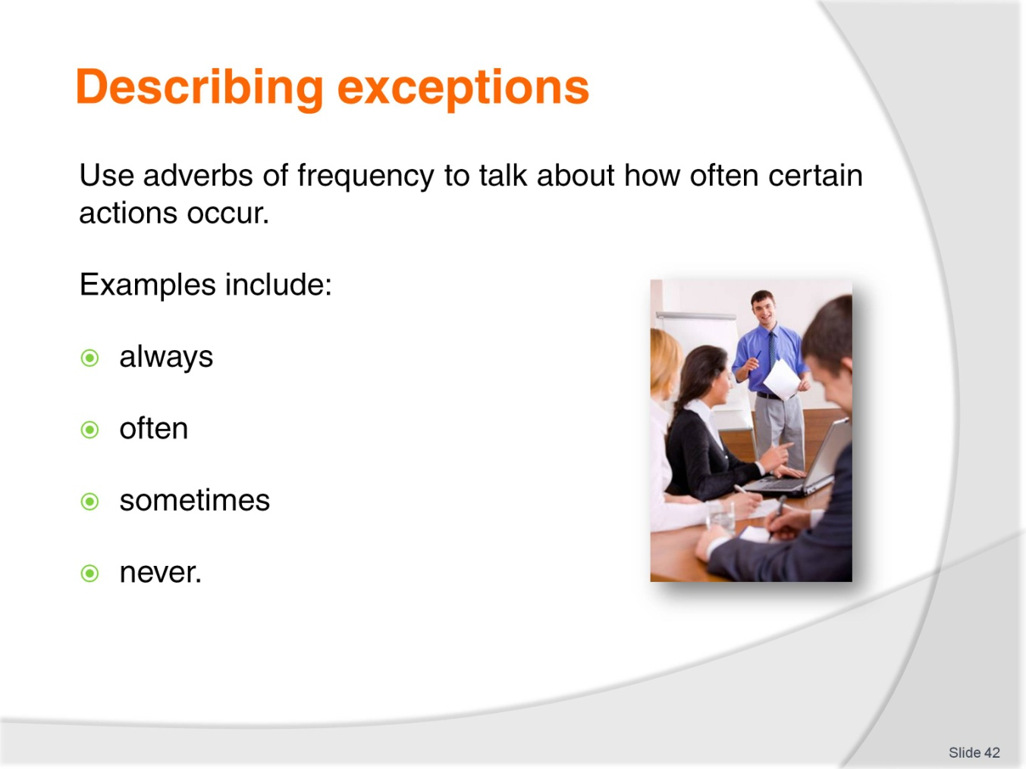
Slide No | Trainer Notes
Trainer instructs students to use adverbs of frequency to describe exceptions to routine procedures. Examples include:
Always
Often
Sometimes
Never.
Trainer asks students to think of more examples of adverbs of frequency.

Slide
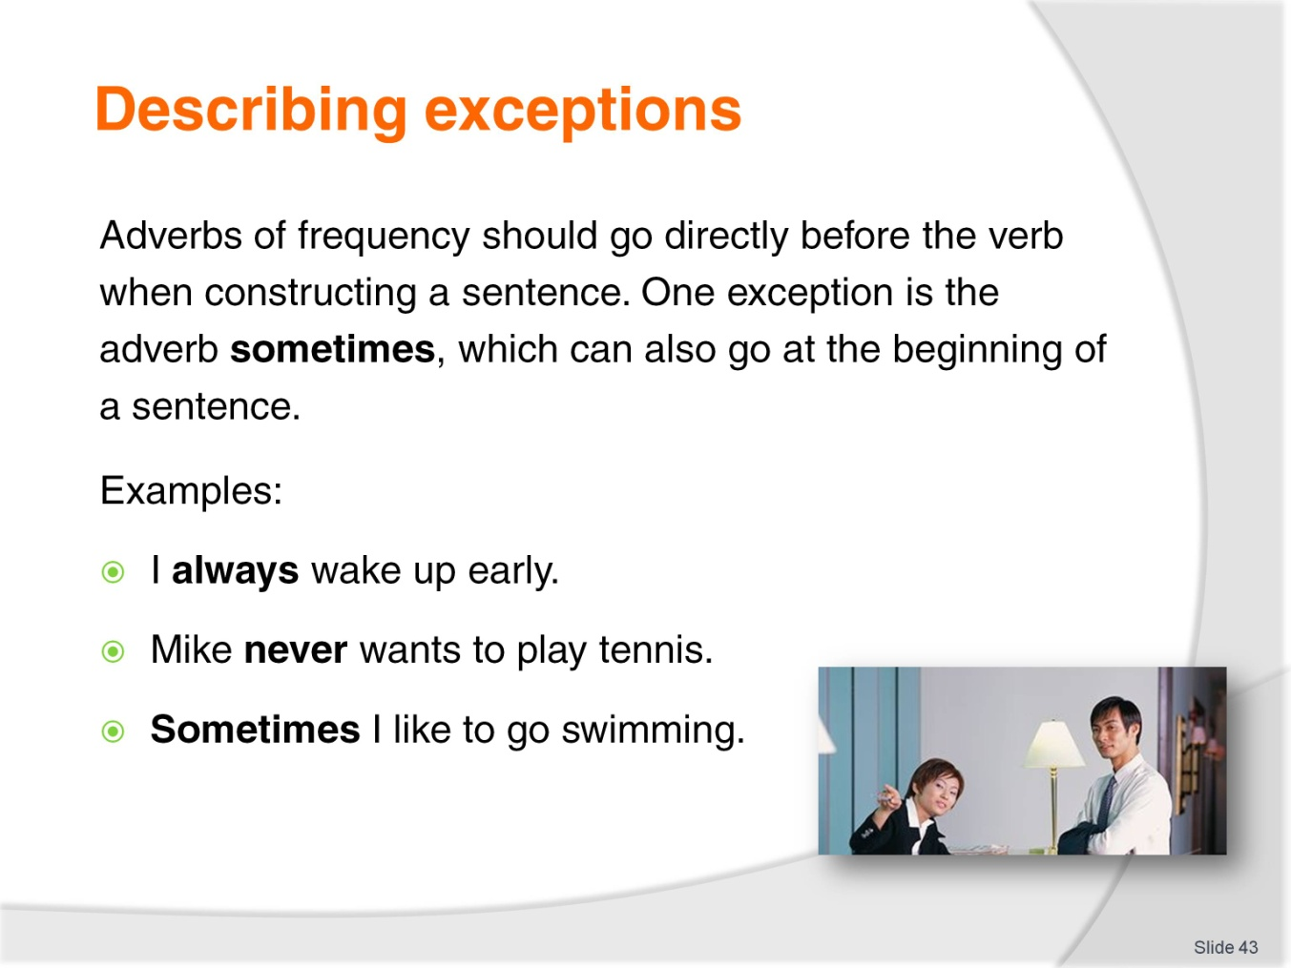
Slide No | Trainer Notes
Trainer describes the grammatical structures used for adverbs of frequency, noting that sometimes can be used at the beginning of the sentence.
Class Activity – Individual
Trainer instructs students to write about their typical day using adverbs of frequency in their Trainee Manual.
Class Activity – Pair work
Trainer instructs students to write about their typical day using adverbs of frequency in their Trainee Manual.

Slide
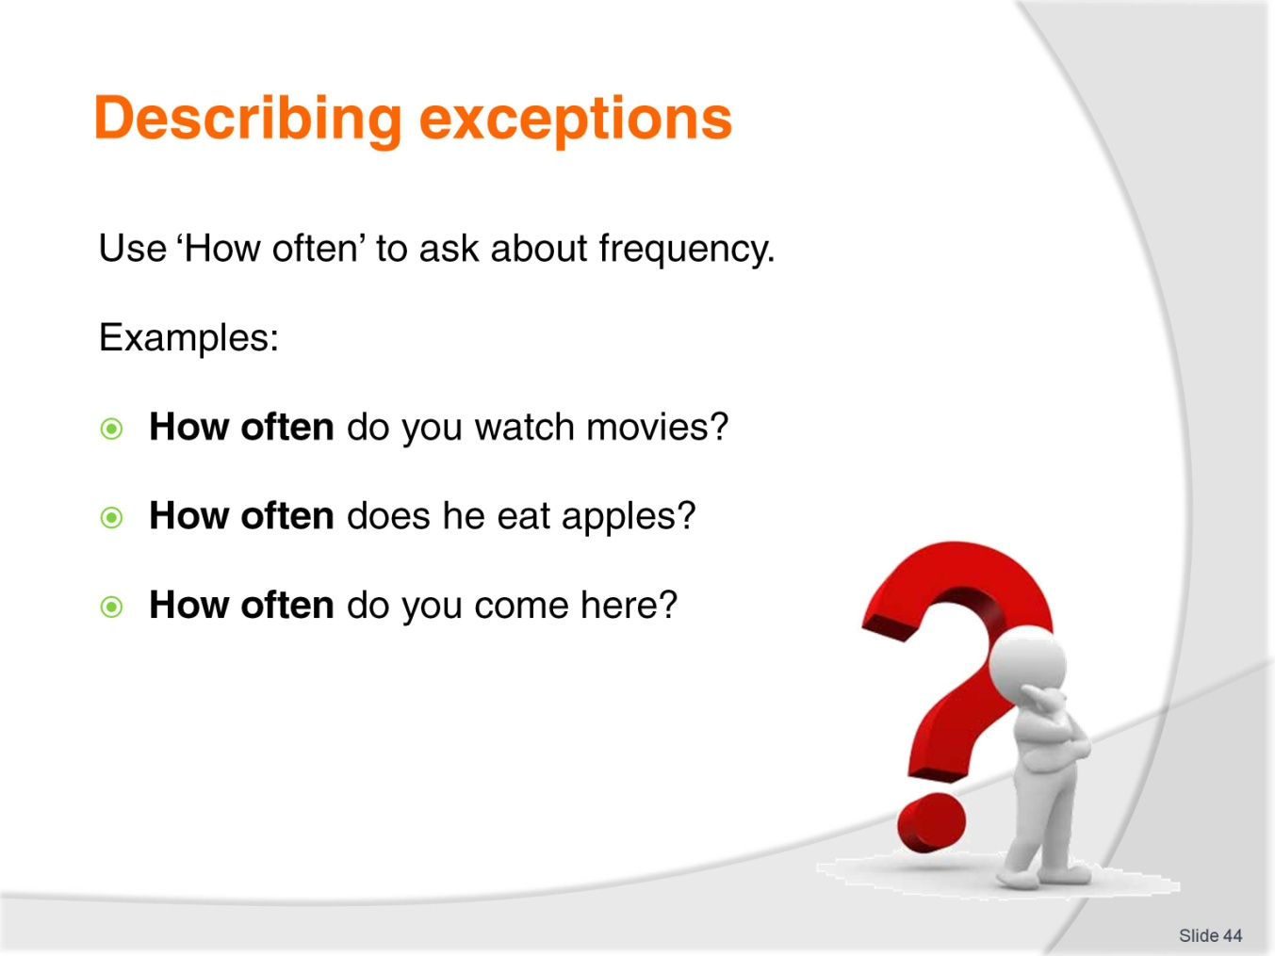
Slide No | Trainer Notes
Trainer describes how to ask about the frequency of an action using ‘How often’.
Class Activity – Individual
Trainer instructs students to list activities they do at work in their Trainee Manual.
Class Activity – Pair work
Trainer instructs students to work in pairs and ask each other about the frequency of these activities. Students should write their partner’s responses in their Trainee Manual.

Slide
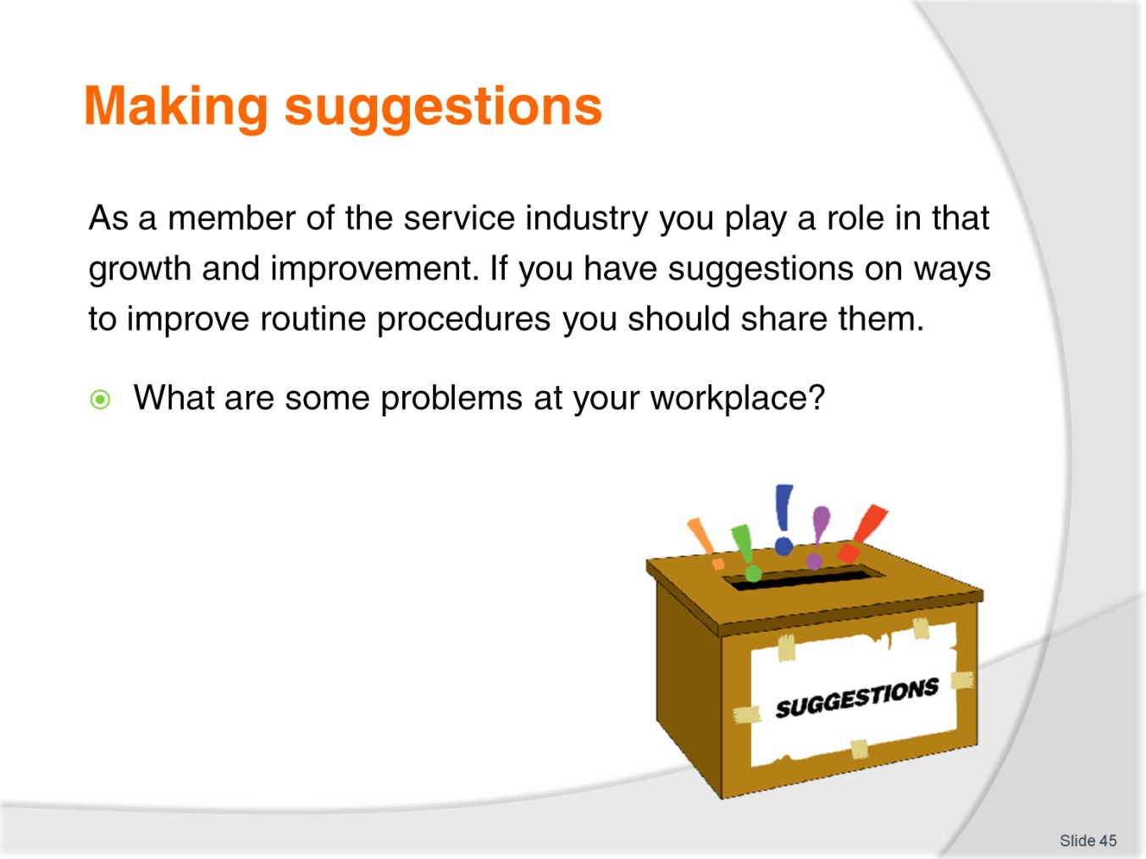
Slide No | Trainer Notes
Trainer introduces the topic by describing his/her ideal working environment.
Class Activity – Group discussion
Trainer asks students to describe their ideal working environment.
Trainer explains that students should feel confident about sharing their opinions on ways to improve working conditions.
Class Activity
Trainer asks students to brainstorm problems with their current workplace and write five of them down in their Trainee Manual.

Slide
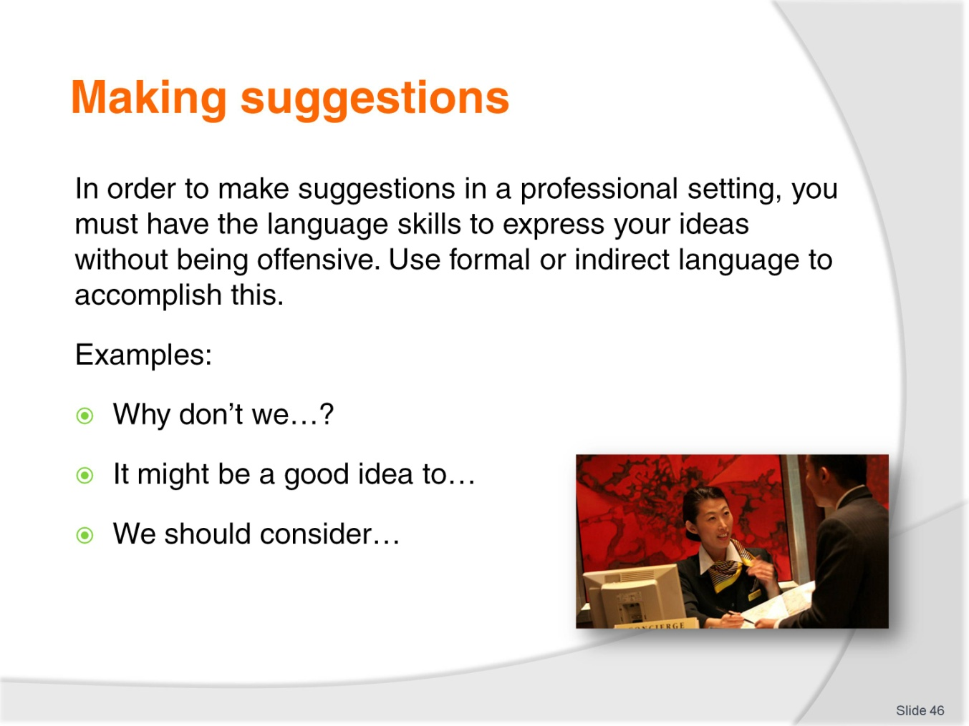
Slide No | Trainer Notes
Trainer explains that students must be professional when making suggestions so they are not seen as being rude or pushy.
Trainer gives examples of appropriate structures, including:
Why don’t we…?
It might be a good idea to…
We should consider…
Trainer asks the students to brainstorm other appropriate ways to make suggestions.
Class Activity – Individual
Trainer instructs the students to use this language to write suggestions to the problems they listed in the first activity.
Class Activity – Listening
Trainer instructs the students to listen to him/her describe problems (below) and write suggestions to improve them in their Trainee Manual.
- Employees in the hospitality industry often change jobs.
- Sometimes hotel staff don’t know how to use a computer.
- It is difficult for many employees to learn English.

Slide
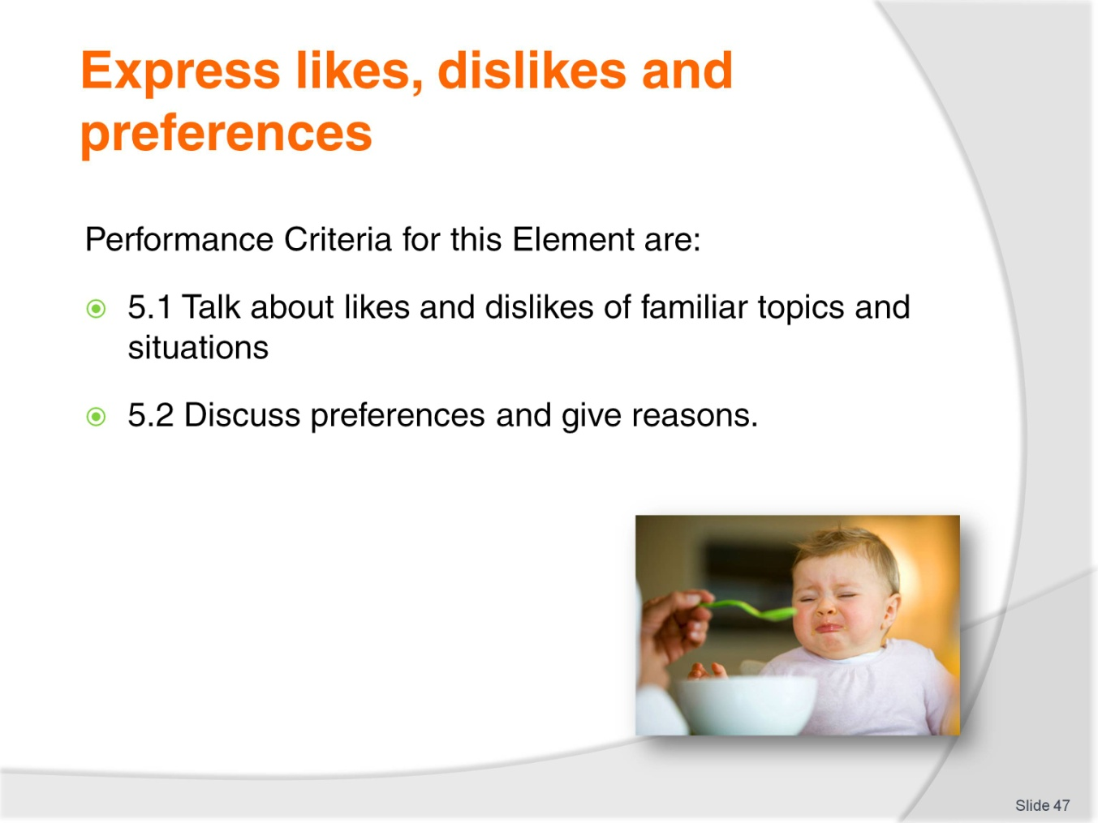
Slide No | Trainer Notes
Trainer identifies the Performance Criteria for this Element, as listed on the slide.
Class Activity – General discussion
Trainer leads a general class discussion on likes, dislikes and preferences, asking questions such as:
Brainstorm some things that you like.
Brainstorm some things that you don’t like.
Is ‘I love’ the same as ‘I like’? What is the difference?
Ok, raise your hand. Who prefers chocolate to vanilla? Oranges to apples? Spring to summer?
Why?

Slide
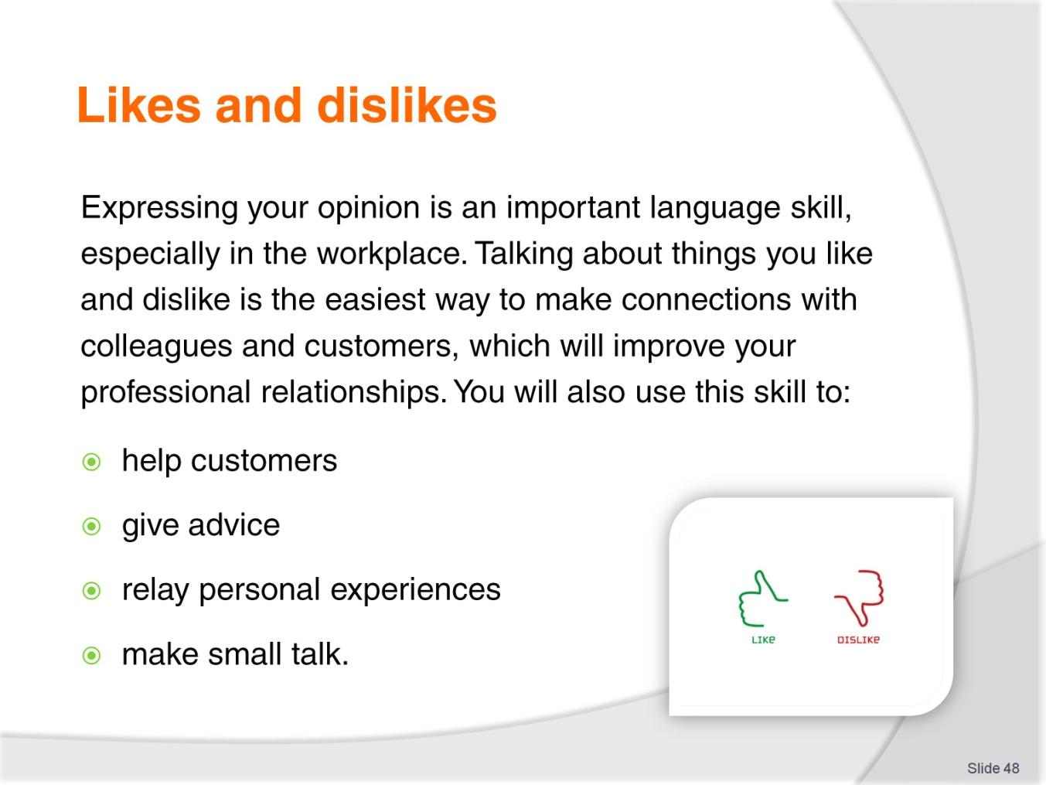
Slide No | Trainer Notes
Trainer emphasizes the importance of the students voicing opinions at work, particularly on like and dislikes. Trainer notes that they will use this skill to:
Help customers
Give advice
Relay personal experiences
Make small talk.

Slide
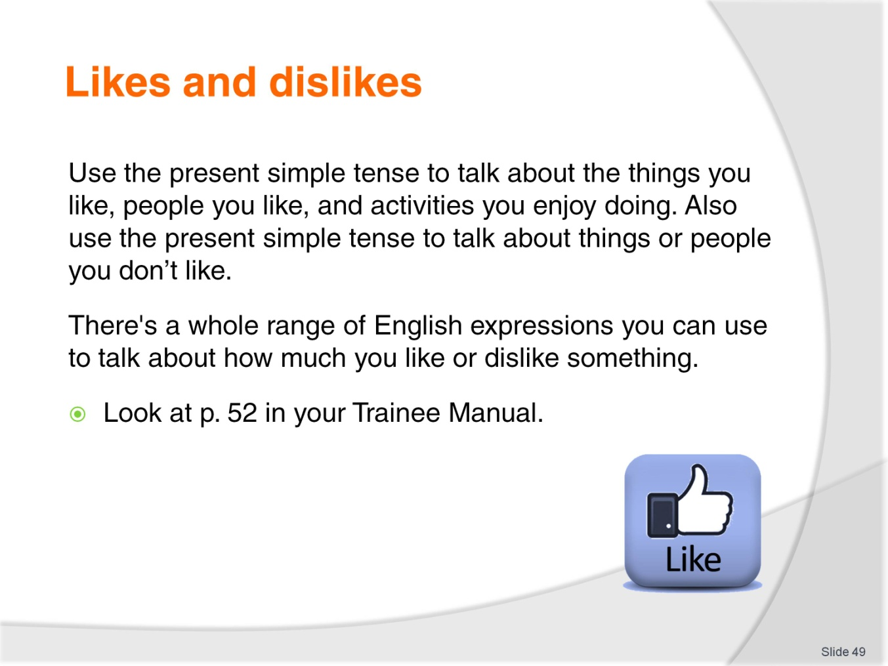
Slide No | Trainer Notes
 | Trainer tells the students to use the present simple tense when describing likes and dislikes. Trainer instructs students to look at the relevant exercise in the Trainee Manual and read the expressions as a class. Trainer asks if students can think of any additional expressions to express likes or dislikes.

Slide
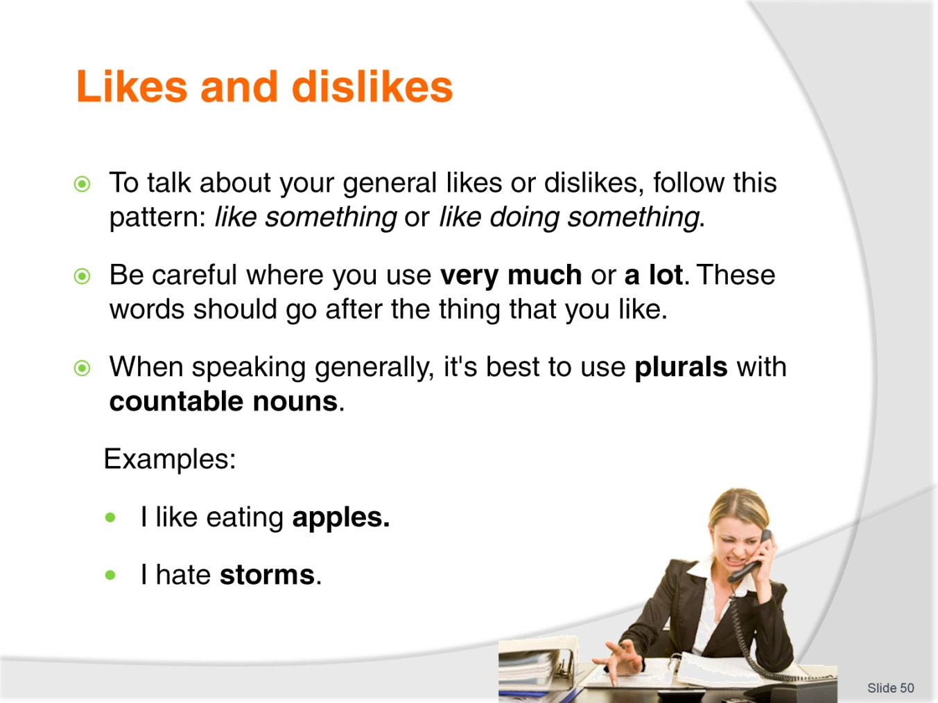
Slide No | Trainer Notes
Trainer goes over the grammatical structures used when expressing likes or dislikes, as outlined on the slide.
Class Activity – Individual
Trainer instructs students to express their likes and dislikes using the prompts in their Trainee Manual.

Slide
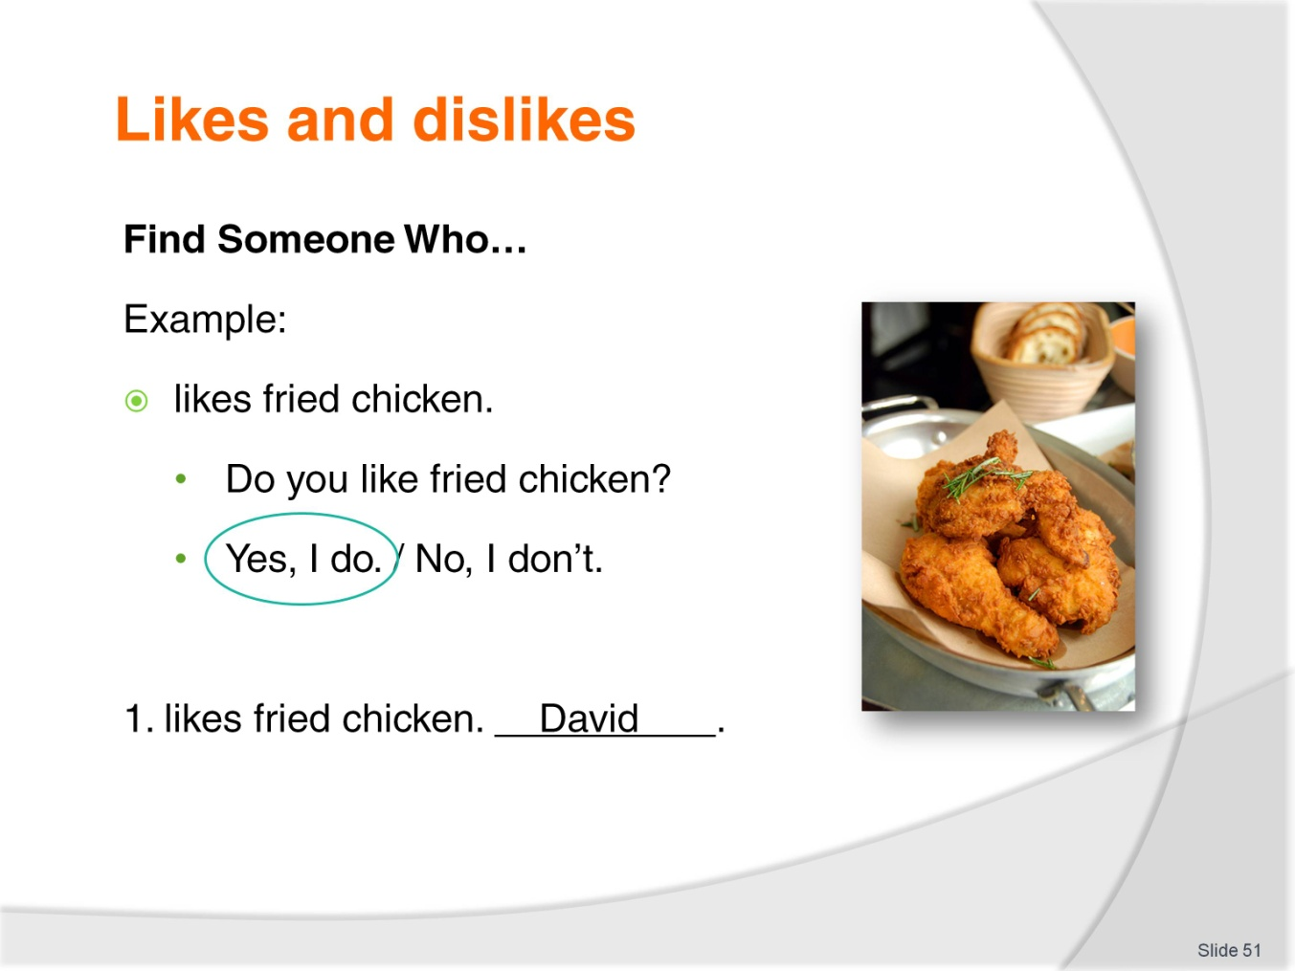
Slide No | Trainer Notes
Class Activity – Mingling
Trainer explains the rules to Find Someone Who.
Students must mingle with their classmates to find out what people like. Students should ask questions to each other, and write down one name for every positive answer. Students should not right down a name for negative answers. They should only write down the same name twice (depending on the number of students).

Slide
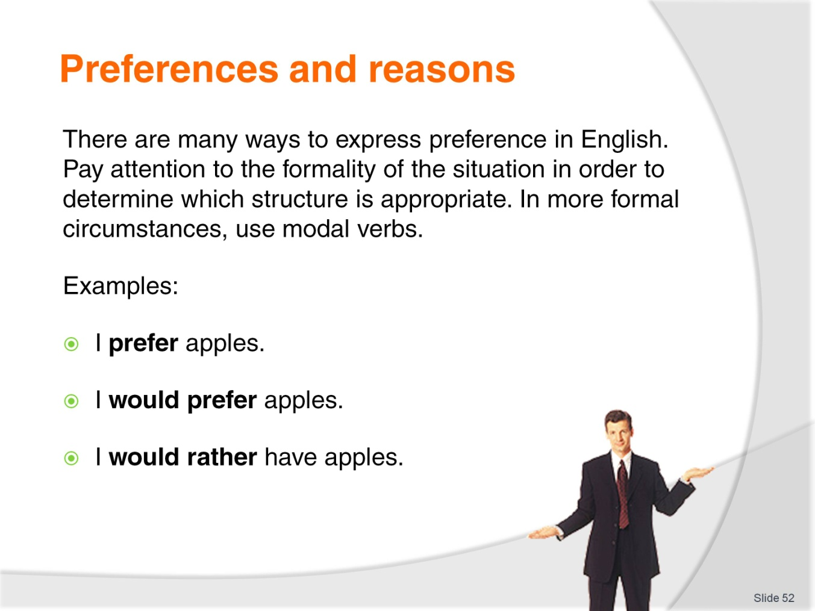
Slide No | Trainer Notes
Trainer explains that the ability to state preferences and give opinions is a necessary skill for employees in any profession. Trainer describes the grammatical structures used to state preference and explains the level of formality for each one.
I prefer apples.
I would prefer apples.
I would rather have apples.
Class Activity – Individual
Trainer instructs students to use this language to state their preference on a variety of topics in their Trainee Manual.
Class Activity
Trainer asks students why they prefer certain things and notes how students give reasons.

Slide
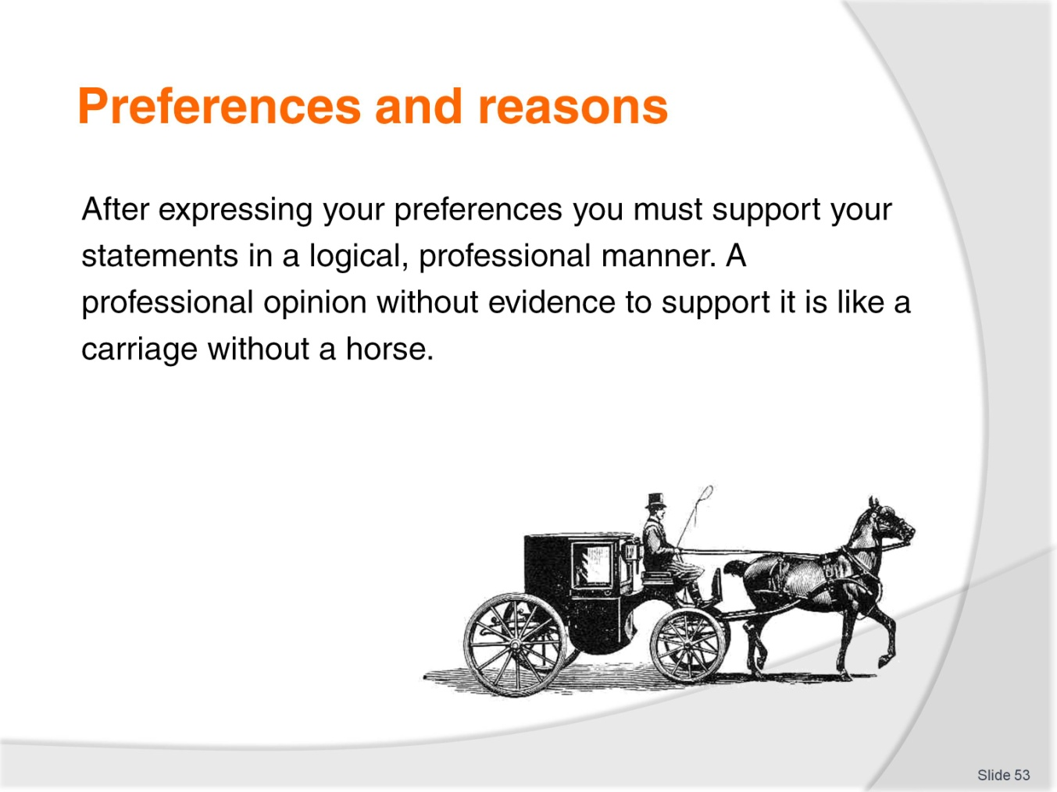
Slide No | Trainer Notes
Trainer explains the importance of giving reasons to support preferences, noting that preferences with support are like carriages without horses.
Class Activity - Individual
Trainer instructs students to read three passages in their Trainee Manual and circle the reasons given for the preferences.
Class Activity – Pair work
Trainer instructs students to work with a partner to give preferences and reasons for one topic listed in the Trainee Manual.

Slide
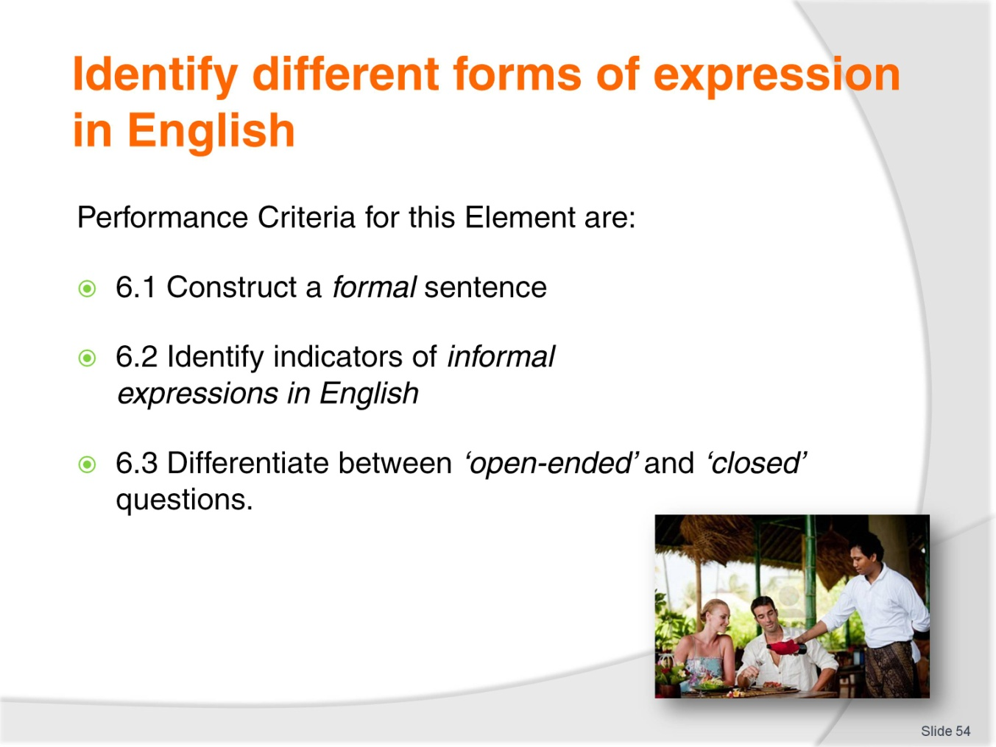
Slide No | Trainer Notes
Trainer identifies the Performance Criteria for this Element, as listed on the slide.
Class Activity – General discussion
Trainer leads a general class discussion on forms of expression in English, asking questions such as:
When should you use formal language?
When is it OK to use informal language?
What are some ways to make sentences more formal?
What is the difference between ‘open-ended’ and ‘closed’ questions?

Slide
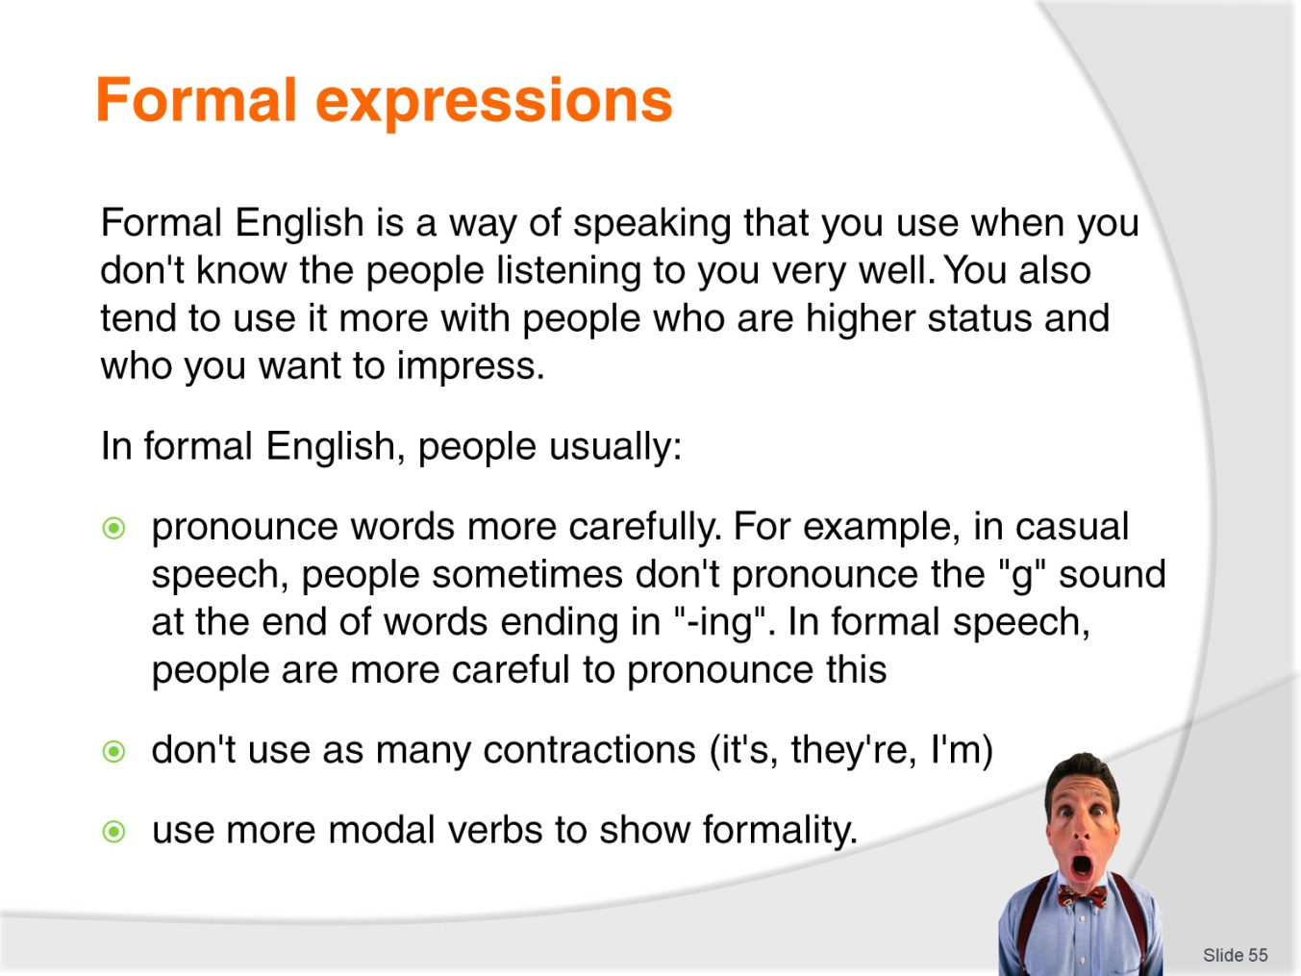
Slide No | Trainer Notes
Trainer describes when it is appropriate to use formal English. Trainer also illustrates how people often construct formal sentences:
Pronounce words more carefully
Don’t use contractions
Use more modal verbs.

Slide
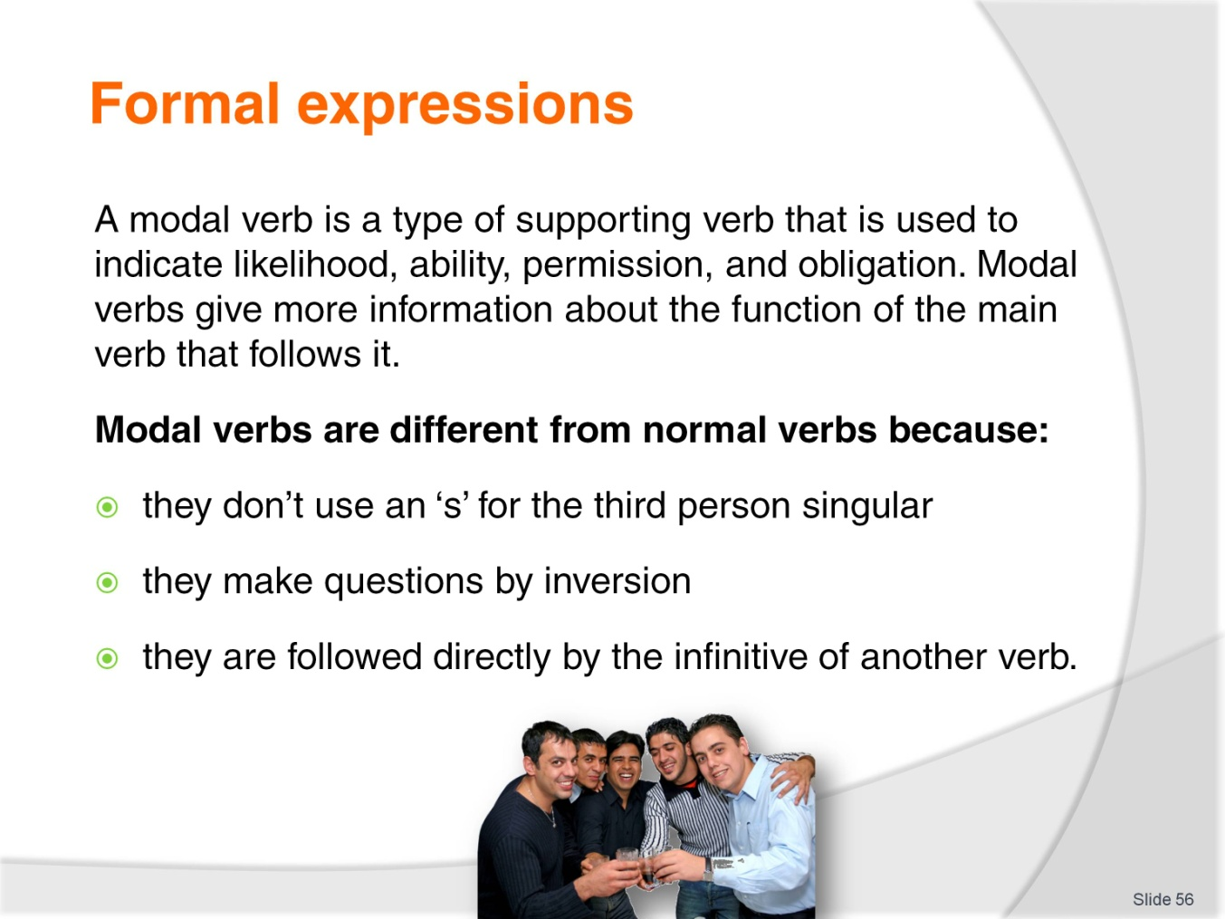
Slide No | Trainer Notes
Trainer explains the grammatical function of modal verbs, noting that modal verbs:
Don’t use an ‘s’ for the third person singular
Make a question by inversion
Are followed directly by the infinitive of another verb.

Slide
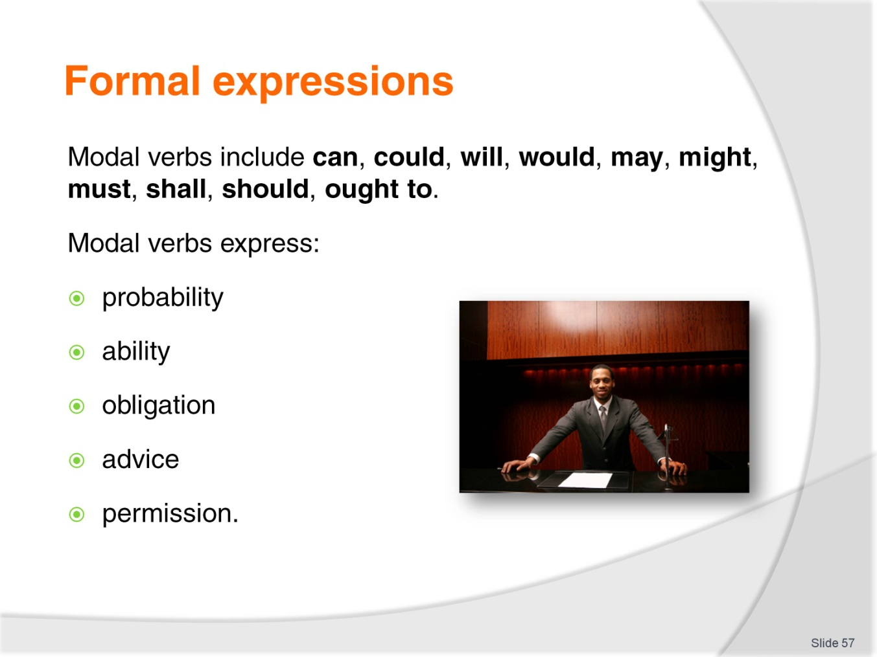
Slide No | Trainer Notes
Trainer gives examples of modal verbs and explains their function (see Trainee Manual):
Probability
Ability
Obligation
Advice
Permission.
Trainer instructs students to read this chart together as a class.
Class Activity – Individual
Trainer instructs students to change the questions listed in the Trainee Manual from informal to formal.
Class Activity – Individual
Trainer instructs students to write formal questions to the responses listed in the Trainee Manual.
Class Activity – Pair work
Trainer instructs students work in pairs in order to practice the dialogues together.

Slide
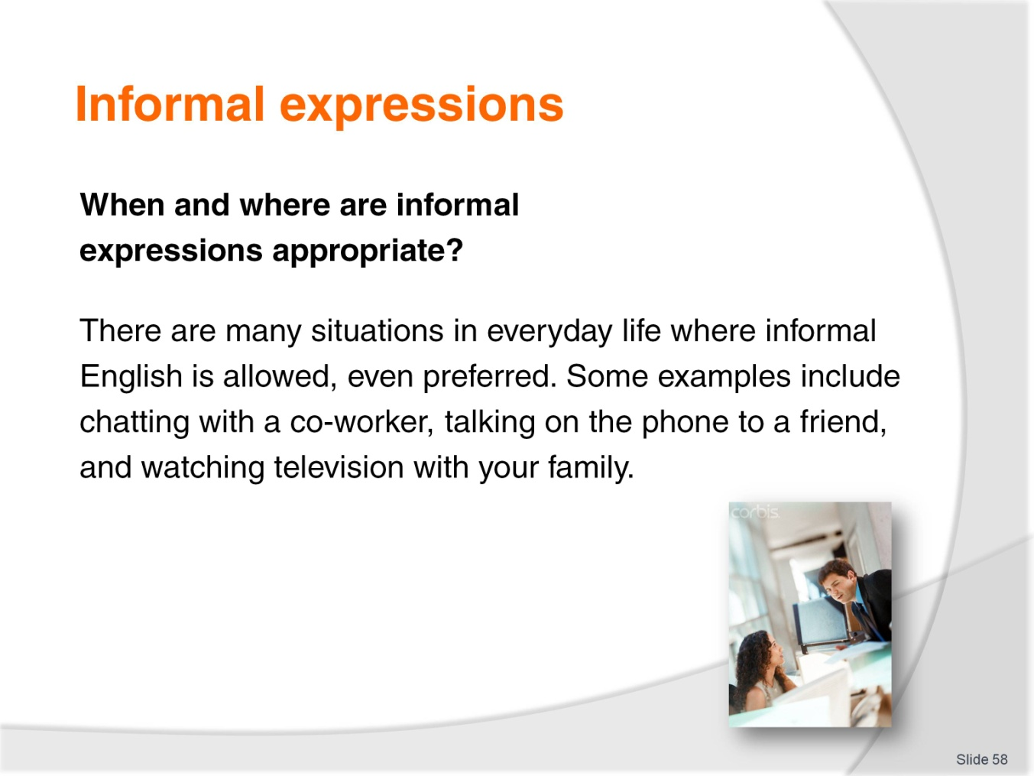
Slide No | Trainer Notes
Trainer asks students when informal expressions are appropriate. Trainer then explains the types of social interactions in which they are appropriate.
Classroom Activity – Individual
Trainer instructs students to read the dialogues in the Trainee Manual and circle examples of informal speech.
Classroom Activity
Trainer asks students to defend their answers.
Classroom Activity – Pair work
Trainer instructs students to work with a partner to practice saying the dialogues together.

Slide
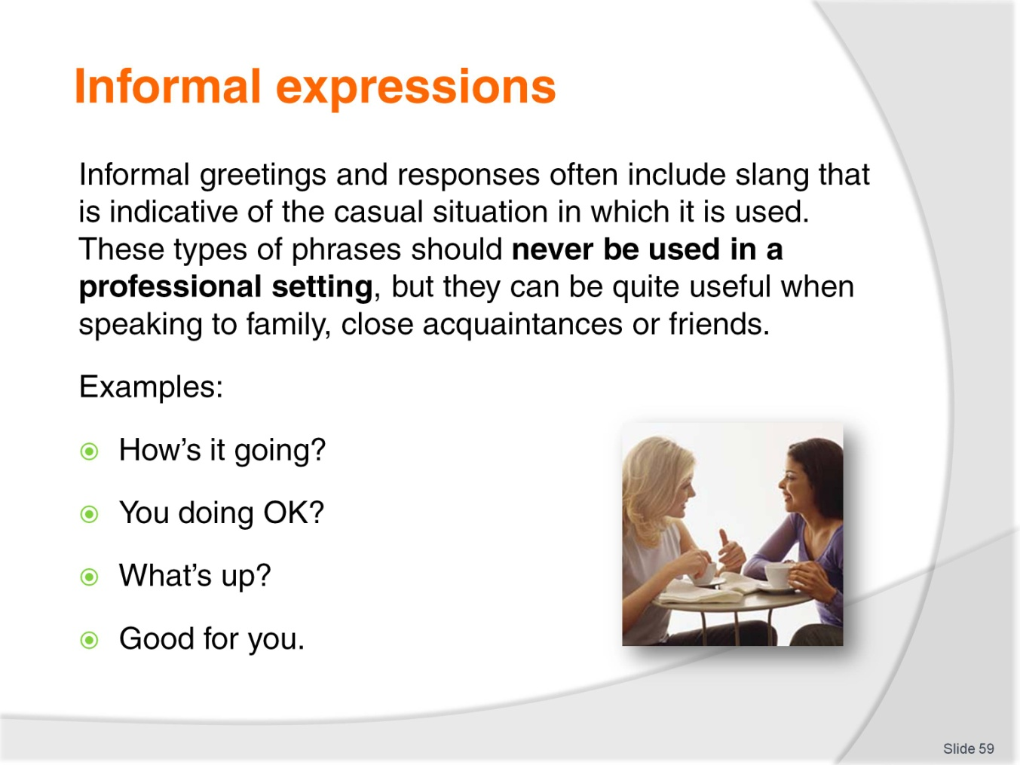
Slide No | Trainer Notes
Trainer explains when students should use informal expressions and gives examples.
How’s it going?
You doing OK?
What’s up?
Good for you.
Trainer asks students to name additional informal expressions and lists them on the board. Trainer instructs students to read the chart in the Trainee Manual as a class.
Class Activity – Individual
Trainer instructs students to circle the informal expressions listed in their Trainee Manual.
Class Activity – Pair work
Trainer instructs students to work with partners to create a dialogue that includes at least 4 informal expressions. Students read the dialogues to the class.

Slide
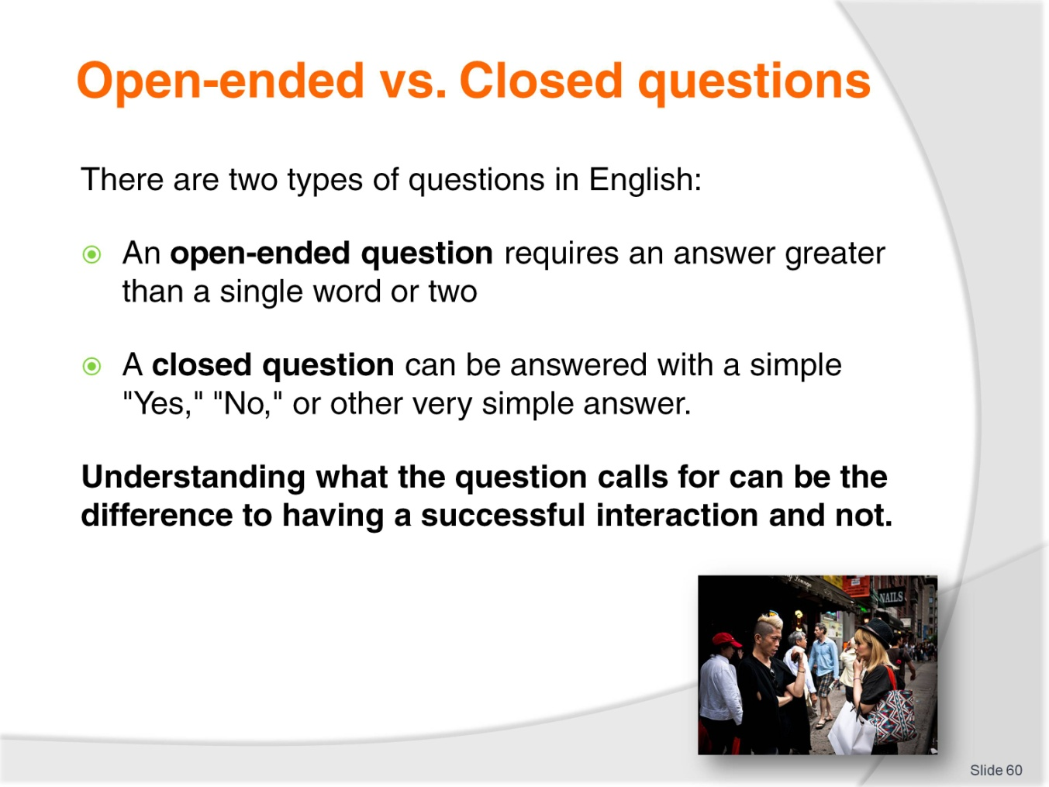
Slide No | Trainer Notes
Trainer explains the difference between open-ended questions and closed questions.
An open-ended question requires an answer greater than a single word or two.
A closed question can be answered with a simple "Yes," "No," or other very simple answer.
Trainer emphasizes that understanding the difference is a very important part of communicating in English.

Slide
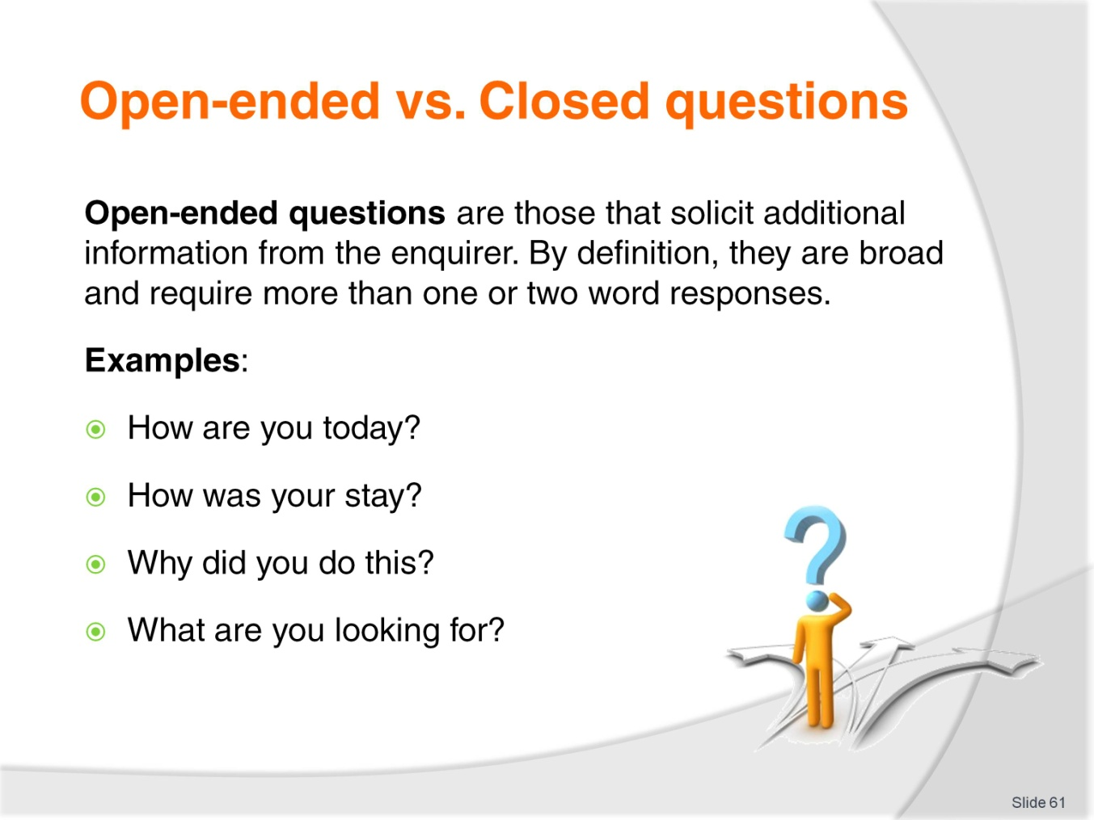
Slide No | Trainer Notes
Trainer further explains the function of open-ended questions and offers examples.
How are you today?
How was your stay?
Why did you do this?
What are you looking for?
Trainer asks the students to brainstorm more examples of open-ended questions.

Slide
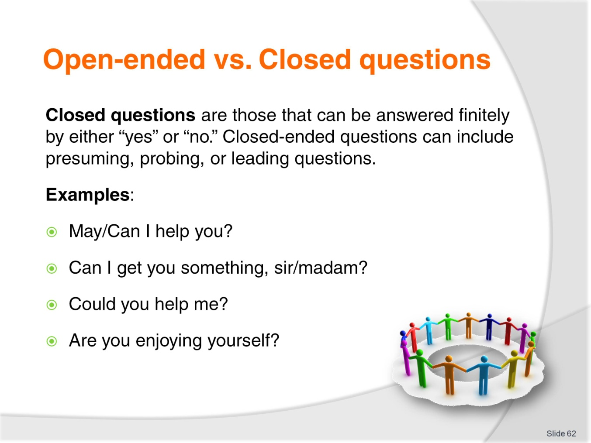
Slide No | Trainer Notes
Trainer further explains the function of closed questions and offers examples.
May/Can I help you?
Can I get you something, sir/madam?
Could you help me?
Are you enjoying yourself?
Trainer asks the students to brainstorm more examples of closed questions.
Class Activity – Individual
Trainer instructs students to read a dialogue in the Trainee Manual and determine whether the questions asked are open-ended or closed.
Class Activity – Pair work
Trainer instructs students to work in pairs to practice reading the dialogue together.

Slide
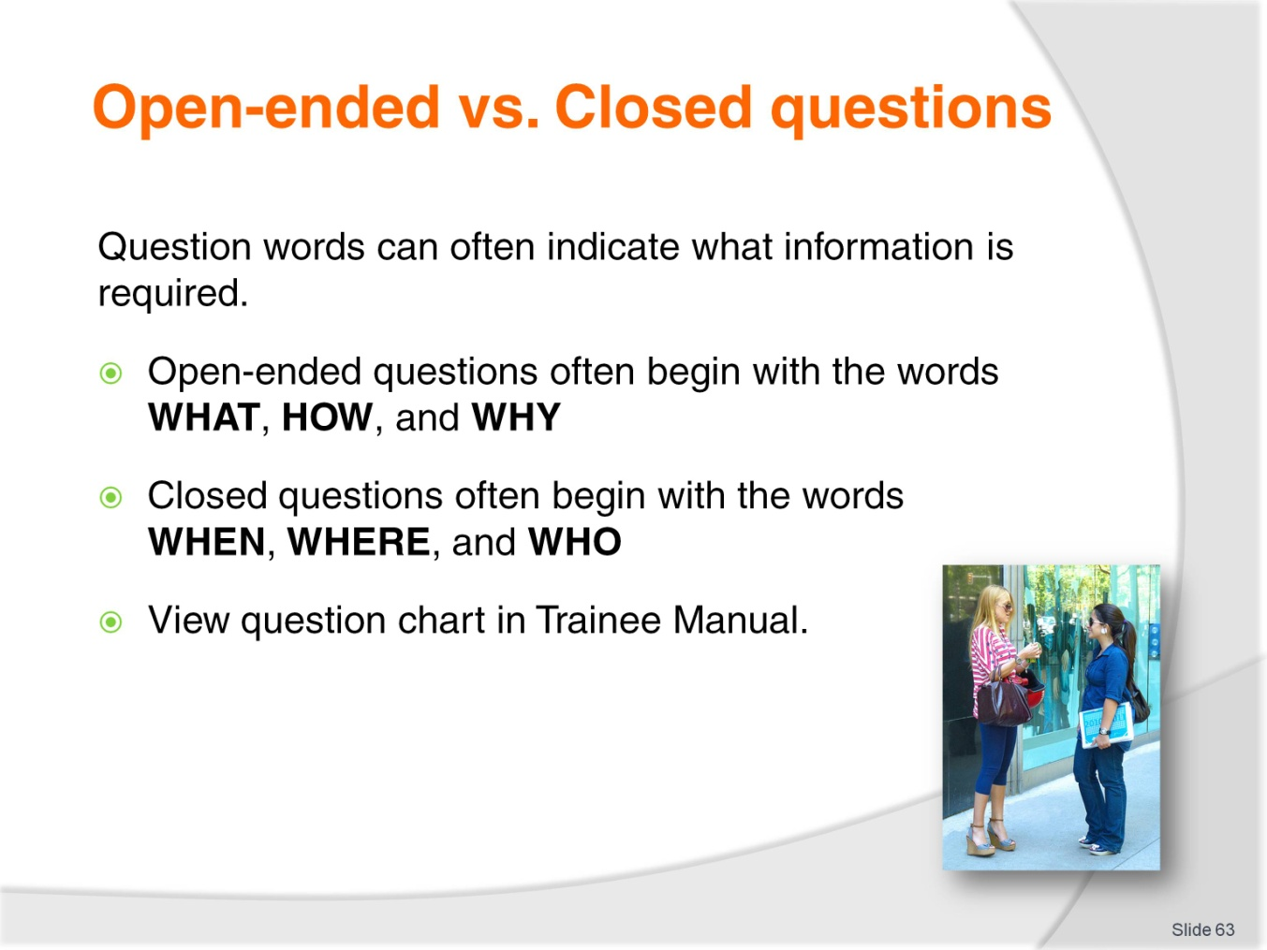
Slide No | Trainer Notes
Trainer describes the question words used to form open-ended and closed questions.
Open-ended questions often begin with the words: WHAT, HOW, and WHY
Closed questions often begin with the words: WHEN, WHERE, and WHO.
Trainer asks the students why they would use certain types of questions at certain times.
Trainer instructs students to read the question chart in the Trainee Manual.
Class Activity – Individual
Trainer instructs students to fill in the blanks to the questions in the Trainee Manual and specify if the question is open-ended or closed.
Class Activity – Pair work
Trainer instructs students to work in pairs to practice reading the questions together.
Class Activity – Individual
Trainer instructs students to write two open-ended questions and two closed questions in their Trainee Manual.
Class Activity – Pair work
Trainer instructs students to ask a partner these questions and record their answers.

Slide

Slide No | Trainer Notes
This is the conclusion of the subject.
Thank the audience and deliver assessments as required.

Recommended training equipment
Full range of equipment which may include lap top computer, data projector, overhead projector, white boards, chalk boards, photocopier, DVD player, TV screen, internet access and CD player.
Consumables – such as white board markers and eraser, white board cleaner, overhead pens, transparencies, paper, butcher’s paper, and industry materials relevant to the training topic.
Sample session plans including blank pro-formas and completed examples of session plans for both theory-based and practical training sessions.
Sample training materials such as handouts, case studies, exercises, workplace manuals, workplace policies and procedures, DVD’s, internet downloads, menus, advertising materials, schedules, price lists, brochures.

Instructions for Trainers for using
PowerPoint – Presenter View
Connect your laptop or computer to your projector equipment as per manufacturers’ instructions.
In PowerPoint, on the Slide Show menu, click Set up Show.
Under Multiple monitors, select the Show Presenter View check box.
In the Display slide show on list, click the monitor you want the slide show presentation to appear on.
Source: http://office.microsoft.com
Note:
In Presenter View:
You see your notes and have full control of the presentation
Your trainees only see the slide projected on to the screen
More Information
You can obtain more information on how to use PowerPoint from the Microsoft Online Help Centre, available at: http://office.microsoft.com/training/training.aspx?AssetID=RC011298761033
Note Regarding Currency of URLs
Please note that where references have been made to URLs in these training resources trainers will need to verify that the resource or document referred to is still current on the internet. Trainers should endeavour, where possible, to source similar alternative examples of material where it is found that either the website or the document in question is no longer available online.

Appendix – ASEAN acronyms
AADCP | ASEAN – Australia Development Cooperation Program.
ACCSTP | ASEAN Common Competency Standards for Tourism Professionals.
AEC | ASEAN Economic Community.
AMS | ASEAN Member States.
ASEAN | Association of Southeast Asian Nations.
ASEC | ASEAN Secretariat.
ATM | ASEAN Tourism Ministers.
ATPMC | ASEAN Tourism Professionals Monitoring Committee.
ATPRS | ASEAN Tourism Professional Registration System.
ATFTMD | ASEAN Task Force on Tourism Manpower Development.
CATC | Common ASEAN Tourism Curriculum.
MRA | Mutual Recognition Arrangement.
MTCO | Mekong Tourism Coordinating office.
NTO | National Tourism Organisation.
NTPB | National Tourism Professional Board.
RQFSRS | Regional Qualifications Framework and Skills Recognition System.
TPCB | Tourism Professional Certification Board.







